President, CEO
Position Description
The Organization Guiding Principles
HealthSpark Foundation (“HealthSpark”) is a private, independent foundation that thrives on a culture of learning and collaboration. It invests in nonprofit organizations, networks, and coalitions promoting a more just and healthy community in Montgomery County, Pennsylvania. The County has sixty-two municipalities, approximately 853,000 residents, with a rapidly expanding and racially/ethnically diverse population.
Created in 2002 from the sale of North Penn Hospital in Lansdale, PA, HealthSpark has become a highly impactful and innovative funder and convener in the county with a key focus on systems change to promote a just and equitable community. Its staff and board are fully invested and committed to using their personal and organizational resources to address racial and social inequities that perpetuate social and economic injustice.
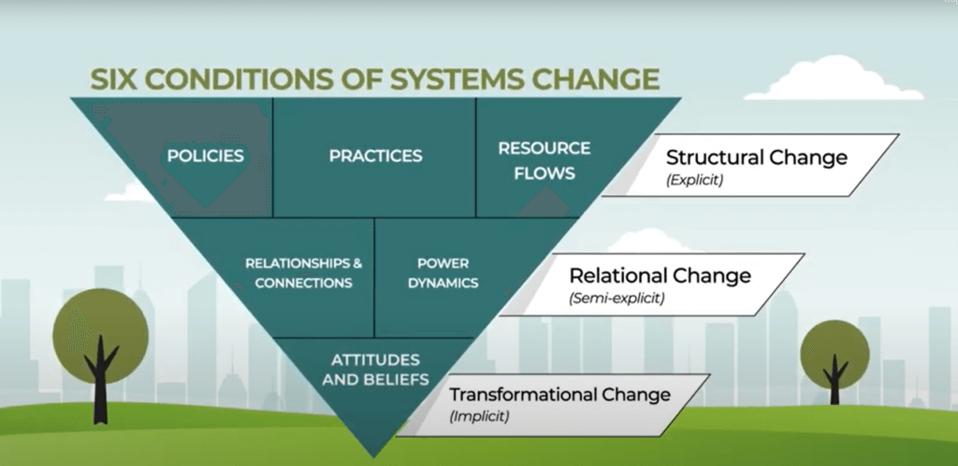
HealthSpark uses its resources to support a more just and effective safety net system through its investments in grantmaking, convenings, research, advocacy, and organizational capacity building. Examples of HealthSpark’ s work includes a bold and innovative ten-year safety net system initiative engaging consumers, providers, governmental and philanthropic leaders, and the Dr. Frank E. Boston Black Justice Fund. HealthSpark also manages the Community Partners Center that functions as the county’s first and only nonprofit center. The Center offers high-quality office space and meeting facilities used by community’s nonprofit organizations.
HealthSpark has assets of $40MM and has dispersed nearly a thousand grants totaling $16,879,335 since its inception. Most grants average $30,000; and the current range of grant awards runs between $5,000 and $250,000 with some multi-year grants. HealthSpark subscribes and strives to implement Trust-based Philanthropy guidelines in its grantmaking practices.
With the announcement of the long-term President & CEO’s December 2022 retirement, the Foundation seeks to hire its next leader. This individual will guide the Foundation to a new period of excellence.

Position Overview:
The President, CEO of HealthSpark Foundation is committed to the values, mission, and goals of the Foundation and is expected to sustain and enhance the reputation of the Foundation as a philanthropic leader within Montgomery County, regionally throughout the Greater Philadelphia area, and across Pennsylvania. The President, CEO will assume a leadership role in the community, both as a spokesperson for the Foundation as well as a catalyst for establishing trusting relationships with philanthropic, nonprofit, and other community partners, generating transformational ideas, and advocating for support of the health and human services safety net system.
The President, CEO works directly with the Board of Directors taking a leadership role in identifying potential board members, exploring board education opportunities; recommending strategies for philanthropic work within the community; and supporting the Board’s goals and vision.
The President, CEO has responsibility for the day-to-day financial and administrative matters of the Foundation and a related entity, 2506, LLC that manages the Community Partners Center. The President, CEO also will respect and reinforce the management skills of staff encouraging proficiency, quality of work performance and setting the highest standards of good management, stewardship, and professionalism throughout the organization.
The President, CEO reports to the Board of Directors.
Major Responsibilities
Strategic Leadership
- Serve as an accelerator in philanthropy for generating innovative ideas, programs, and supports for health and human services organizations.
- With input from the team and board, design, review, maintain, and implement all operational policies and guidelines for the Foundation.
- Keep abreast of current trends in philanthropy, federal/state policy, and local (county/municipal) policies and practices impacting the safety net system. Share this expertise to guide the Board and its work in the community.
- Prepare, develop, and ensure the timely distribution of all Board and Committee materials including agendas, meeting packages and presentations taking a co-leadership role with the respective Board/Committee chairs.
- Participate in all Board Committees (developing agendas, coordinating activities, preparing meeting minutes, and implementing directives).
External Relations/Communications
- Function as primary spokesperson and liaison representing HealthSpark’s mission to increase the awareness/brand.
- Work with the broader community, including related philanthropic organizations, media, public sector, and civic leadership. Be visible.
- Assume a leadership role in the county and more broadly with key stakeholders in civic, political, and other spheres of alliance and influence.
- Educate and assist citizens, public officials, grant makers, nonprofit organizations, faith groups, and businesses in understanding the mission and interests of the Foundation.
- Provide consultation to nonprofit organizations and their leadership on issues and services such as fundraising, strategic planning, grant writing, evaluation, volunteer services, organizational development, job-seeking, and group facilitation skills.
- Attend and participate in important and relevant programs with local, state, and federal affinity groups to sustain contemporary awareness and learning of grantmaking opportunities and philanthropic industry trends.
Financial
- Working with the CFO, oversee the preparation and presentation of the annual budget for review and approval by the Board of Directors.
- Monitor the operating budget and cash flow requirements.
- Oversee the production and filing of all regulatory reports.
- Conduct all financial transactions in accordance with the policies and directives of the Board of Directors.
- Oversee the preparation of financial and investment statements, audit, and other financial reports to ensure all Foundation spending and investment activities are consistent with established Board policy and procedures.
- Serve as the primary contact to the Out-sourced Chief Investment Officer firm and manage day-to-day investment portfolio and banking activities.
- Monitor implementation of asset allocation, selection and performance of managers, and overall investment portfolio performance.
- Support board/committee efforts to define, implement, and monitor Mission Aligning Investing strategies.
- Monitor and oversee risk management and legal work with insurance brokers and outside legal counsel.
Grantmaking
- Lead the design and focus of grantmaking activities including proposal solicitation, review, and feedback to applicants.
- Oversee the grant award processes, disbursement of funds, reporting and grants management.
- Develop a deep understanding of the county government, and other important constituents to understand the big picture and encourage a collaborative network.
- Seek out and nurture trusting relationships and partnerships with community stakeholders including consumers, funding partners, service providers, advocates, policymakers, and others.
- Align grantmaking with the Foundation’s mission.
- Recommend strategies for philanthropic engagement with the community.
- Embrace analytics/metrics when evaluating the outcomes of the Foundation’s work.
- Design and implement board learning opportunities bringing grantees to present and discuss their work and to offer insights and feedback about the nature and value of partnering with the Foundation. Encourage Board involvement with Foundation activities such as symposia, meetings, and conferences.
- Ensure effective and innovative grantmaking initiatives.
Human Resources
- Establish and maintain a professional, engaging, exciting, and nurturing team environment.
- Support a high performing staff through regular team meetings, individual discussions, professional development opportunities, and constructive feedback
- Ensure staff is motivated, understands the goals of the organization, and has clear responsibilities.
- Hire for optimal staff capacity.
- Conduct productive performance evaluations to ensure appropriate alignment with the Foundations’ strategic and operational goals.
2506, LLC
- Serves as President, CEO of 2506, LLC supporting the board of managers in its oversight and management of Community Partners Center.
- Oversee vendor selection, contracting, and monitoring to maintain a Class A Professional Office building and surrounding campus.

Critical Skills and Qualifications
- Personal commitment to addressing institutional racism and social injustices and racial inequities
- Leadership. organizational management and operational experience.
- Experienced in program development, including strategic planning and evaluation of programs.
- Understand grantmaking and the nonprofit sector.
- Systems thinker, convener.
- Master’s degree preferred.
- Excellent verbal and written communication skills.
- Skillful in facilitating group process and team building in both a virtual and in person format.
- Flexible.
- Able to prioritize tasks, establish and meet deadlines.
- Able to collaborate effectively with consultants and financial representatives.
- Experience in managing an institutional investment portfolio, Modern Portfolio Theory, and Mission Aligned Investing
- Able to analyze data.
- Creative problem solver.
- Excellent people skills.
- Residence in Montgomery County, Pennsylvania is strongly preferred.
Personal Traits
- Curious, empathetic, personable, high EQ.
- Forward thinking, inspirational, strategic, passionate, innovative.
- Servant leader with energy, vision, and a sense of humor.
- Self-directed, creative, entrepreneurial.
CONTACT INFORMATION
To learn more about this opportunity, please, please contact:
Beth Hare, Marni Murphy or Edy Penn
Criterion Search Group
administrator@criterionsg.com
610-581-0590

