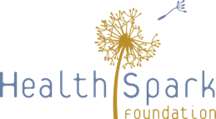
Community of Practice
March 17, 2021

How are you thinking about and prioritizing health and wellness – for yourself, your team, your organization?
What are you thinking about what comes next for your organization and Montgomery County’s safety net system?
What do you see as the opportunities and challenges to advance social justice and racial equity in Montgomery County’s safety net system?
What do decision makers and funders need to know to support a successful transition and support a just and financially resilient safety net system?
Reflecting on the past year, what lesson did you learn about your work and Montgomery County's safety net that can be applied to building a more just and resilient safety net in the future?
To share your responses, please email your completed form (Word doc or scanned copy) to ehertz@healthspark.org.

