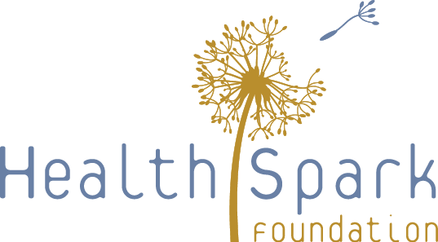

Build Back Better Design Team Session 3: July 1, 2020

Objectives:
- Build on ideas from Sessions 1 and 2
- Dig into some key strategy questions

Agenda:
- Welcome
- Small Group Discussion 1: Our Vision and Goals
- Full Group Discussion
- Small Group Discussion 2: Big Questions
- Full Group Discussion
- Next Sessions:
  - July 15: Strategy development and questions
  - July 29: Final recommendations and what comes next
- Adjourn

