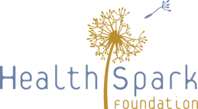

Build Back Better Design Team: June 3, 2020 Worksheet
Observations of Montgomery County’s Safety Net System
How well has the safety net system responded to the community’s needs during the COVID-19 pandemic? | - Doing great  - Doing fine  - Struggling but holding up  - On the verge of breaking down  - It has failed | Your reflections:
What challenges have you experienced? Be specific about cracks, damages, losses.
What has gone well? Be specific about strengths in your organization, networks, community.
What interdependencies among the various pieces of the safety net system have emerged, been expanded, or been exasperated? Consider nonprofit providers, schools, public safety, and others.

Our Vision for Montgomery County’s Safety Net System
Vision:  Imagine an effective recovery and reconstruction of the safety net system that makes it better than ever before – what does it look like? | Shared Principles:  What shared principles need to shape and be upheld in a better safety net system? | Goals:  What are clear targets – not general policy statements – that we should aim to achieve?
What recovery issues and barriers do we need to address to achieve that vision? | What stands out as being most important to build back better – to make sure we go beyond the status quo that we’ve known? | Who needs to be engaged to make these goals a reality?

