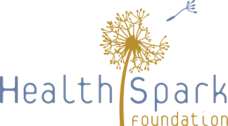
Build Back Better Design Team: June 17, 2020 Worksheet 2

Component | Your Reactions and Ideas
Vision:
- Person-centered
- Connected
- Well-resourced
- Equitable
- Respected
- Prepared
- United

Guiding Principles:
- Common voice
- Equal access
- Dignity and respect
- Community
- Partnership
- Intentional anti-racism work
- Person-centered

Goals:
- Centering DEI and anti-racism work
- Structural funding changes
- Social fabric
- Replicate good models
- Technology
- Financial sustainability practices
- Emotional and mental health services
- Prioritizing vulnerable populations
- Coordination
- Outreach and access

