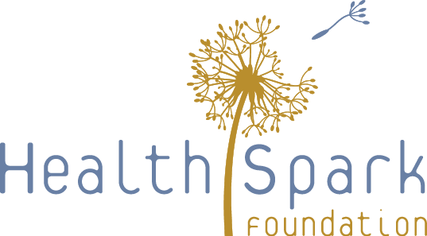

Build Back Better Design Team Session 2: June 17, 2020

Objectives:
- Review survey findings and ideas that surfaced during Session 1
- Discuss implications and emerging priorities
- Ensure a social and racial justice frames the discussion and development of recommendations

Hopes for the Process – Three Words from Session 1 (partial list from both groups):
  - Let’s do this
  - Crisis creates opportunity
  - Hands on partnership
  - Lasting meaningful collaboration
  - Plan of action
  - Push envelope now
  - Rise up
  - Support compassion hope
  - Future possibilities together
  - Deepening collaboration and compassion

Agenda:
- Welcome
- Review of Key Findings
- Small Group Discussion: Reactions and Implications
- Full Group Discussion
- Next Sessions
- July 1: Strategy development
- July 15: Strategy development
- July 29: Final recommendations for strategies
- Adjourn

