Best practices guide for Montgomery County food pantries
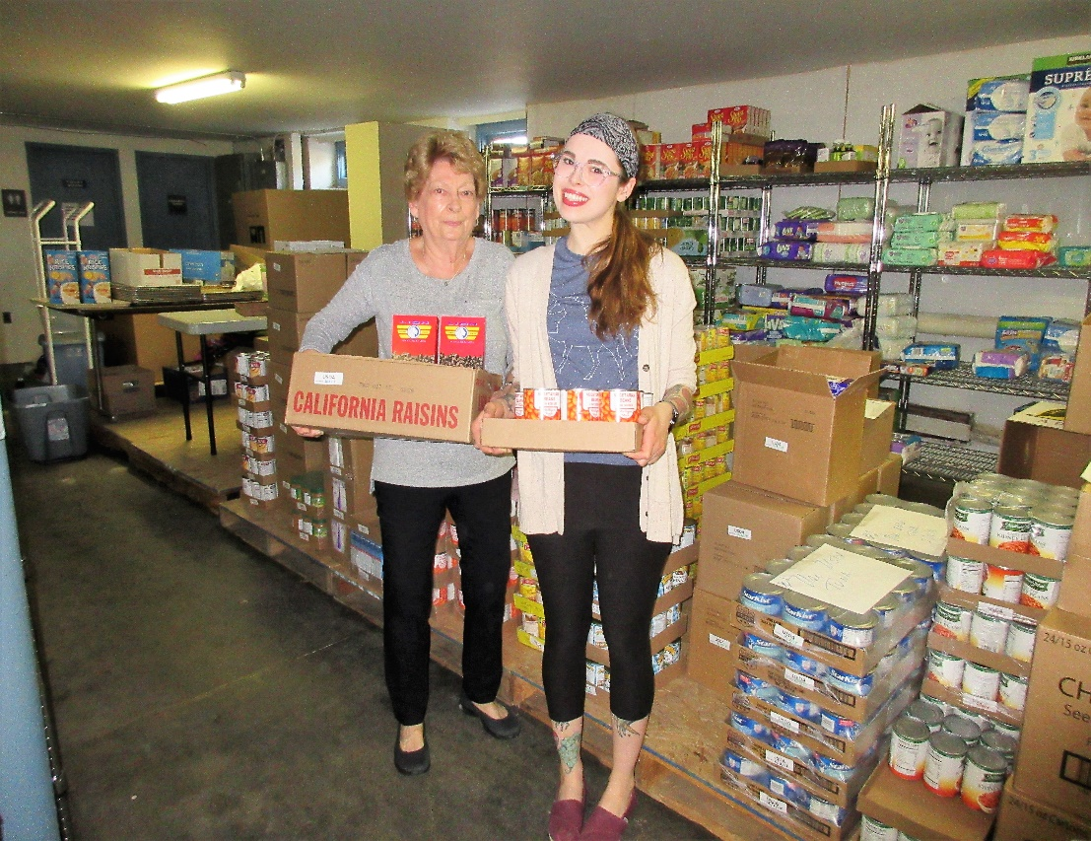
2019 | COMMISSIONED BY HEALTHSPARK FOUNDATION  CREATED BY COALITION AGAINST HUNGER
Table of Contents
ACKNOWLEDGEMENTS
1 INTRODUCTION
1-1|Letter from HealthSpark Foundation
1-2|Hunger in Montgomery County
2 OPPORTUNITIES TO MEET THE NEED IN YOUR COMMUNITY
2-1|Should You Start a New Pantry?
2-2|What Changes Should You Make to Your Existing Program?
2-3|Should You Merge Your Pantry with Another Pantry to Increase Your Impact?
3 PARTNERING WITH OTHER ORGANIZATIONS
3-1|Special Partnership Opportunities for Montgomery County Food Pantries: MontCo Anti-Hunger Network, Regional Coalitions and Peer Learning Circle
3-2|Partnering with Other Social Service Programs in Montgomery County to Meet Your Participants’ Non-Food Needs
4 PHYSICAL/SOCIAL ENVIRONMENT, NUTRITION AND FOOD SAFETY
4-1|Physical Environment (Includes Choice/Pre-Packaged/Hybrid Models)
4-2|Social Environment
4-3|Nutrition
4-4|Food Safety
5 FINDING FOOD FOR YOUR PANTRY
5-1|Philabundance
5-2|Share Food Program
5-3|Independent Partnerships with Grocery Stores
5-4|Food Drives
5-5|Sharing Food with Other Pantries
5-6|Requesting Food via Social Media
5-7|Farms/Community Gardens
5-8|Addressing Food Allergies and Sensitivities
5-9|Addressing Cultural Food Preferences
5-10|Food for the Holidays
6 FINDING MONEY TO RUN YOUR PANTRY
6-1|Foundations
6-2|Fundraising Events
6-3|Individuals
6-4|Religious Sources
6-5|Additional Resources
7 MANAGING YOUR PANTRY
7-1|Communicating Effectively
7-2|Transportation
7-3|Volunteers
7-4|Recordkeeping (Participant Tracking, Inventory, Contracts, etc.)
7-5|Caring for Your Equipment
7-6|Succession Planning
8 ADVOCACY
9 THE FUTURE
APPENDICES
A|Food Pantry Assessment
B|Referrals for Other Sources of Food in Montgomery County
C|Contact Information for Montgomery County Non-Food Referrals
D|Additional Nutrition and Health Resources
E|Additional Products Pantries Offer Participants Beyond Food
F|About HealthSpark/About Coalition Against Hunger/About MontCo Anti-Hunger Network

Acknowledgements
This best practices guide would not be possible without the invaluable input from many wonderful people involved with food pantries in Montgomery County, including Jennifer Barnhart, Mindy Bartscherer, Carol Bauer, Christine Bouley, Stuart Bush, Sean Breslin, Arlin Delp, Cindy Dembrosky, Kristyn DiDominick, Pat Druhan, Marsha Eichelberger, Carole Exley, Jo Fagan, Joyce Goodwin, Brian Gralnick, Janet Hague, Devin Hunter, Karen Kaminskas, Sandy Knight, Kary and Nanette LaFors, Joe Maccolini, Tom McGlynn, Deirdre Mulligan, Suzan Neiger Gould, Liz Peteraf, Britt Peterson, Robin Rifkin, Jack Santry, Paula Schafer, Lisa Schilansky, Fr. Mike Sowards, Loretta Stever, Gigi Tevlin-Moffat, Patrick Walsh, Eli Wenger, Susan Wenrick, Barbara Wilhelmy, Rev. Zuline Wilkinson and Steveanna Wynn. Thank you for generously sharing your time and knowledge through participating in interviews, focus groups and reviews!
We would also like to thank Hunger Free NYC for sharing their template for their Soup Kitchen and Food Pantry Best Practices Guide with us.

1 introduction

1-1|Letter from HealthSpark Foundation
HealthSpark Foundation has long supported systems change efforts in Montgomery County to strengthen the capacity of organizations to provide quality programs and services in a financially sustainable manner. In 2013, the foundation began focusing on the emergency and supplemental food system in the county, working largely with the county’s food pantries. Foundation staff conducted numerous site visits and community meetings to learn about the food pantry system and the complex relationships pantries must manage to offer healthy food to their clients. We heard a compelling request for a best practice guide. Moreover, we uncovered a vast volunteer and professional network of caring people interested in ending hunger and food insecurity in the county. In response, HealthSpark Foundation commissioned the Coalition Against Hunger to research and write this food pantry best practices guide.
The Coalition conducted numerous interviews with food pantry staff and volunteers. They observed a powerful and consistent message among large, medium and small-scale pantries: that meeting the needs of their community members is the reason pantries keep their doors open week after week.
Still, some pantries understand it is NOT always feasible to continue to struggle to keep their doors open – or to start a new pantry – when there is likely a pantry close by and the primary sources of food are already committed to existing pantries.
HealthSpark Foundation believes this pantry manual will help ensure the county’s emergency food system continues to evolve and operate as efficiently and effectively as it can to serve those in need of nutritious food. We invite all pantries operating in Montgomery County to use this guide and adopt the best practices outlined here that are best suited to their mission and the unmet needs of their community.
The foundation recognizes the need for a strong and sustainable emergency food system and recommends that:
- Opening additional pantries in the county should be strongly discouraged in favor of strengthening existing pantries.
- Pantries should regularly work together to fundraise, collaboratively schedule and hold food drives and join in advocacy efforts, which will help to strengthen the entire emergency food system.
- Struggling, low-volume and limited access pantries should strongly consider merging with larger programs or wrap up their operations.
We thank the professionals and volunteers who dedicate their time and energy to helping some of the most vulnerable individuals and families in our county. We commend their efforts and invite them to consider adopting these practices to help them continue to succeed in achieving their mission.

Russell Johnson Tamela Luce
President & CEO Senior Program Officer

1-2|Hunger in Montgomery County
Many people believe that hunger and food insecurity only occur in urban areas, but unfortunately hunger affects every community and lurks around every corner.
In Montgomery County – the second wealthiest county in Pennsylvania – more than 77,000 individuals (9.5%) are food insecure. Equally troubling is the fact that almost 22,000 children (12.1%) in the county are experiencing food insecurity, putting their future health and well-being at risk. (Feeding America Map the Meal Gap 2016)
Food insecurity is the lack of access to enough food for a healthy, active life.
Families in the county struggle to put food on the table due to many factors including high rents and housing costs, low wages and cuts to food assistance safety net programs like the Supplemental Nutrition Assistance Program (SNAP/Food Stamps). Heeding the call to feed their neighbors, approximately 50 food pantries in Montgomery County have opened their doors to provide food.
To better understand who is hungry in Montgomery County and the needs of pantry participants throughout the county, in 2017 HealthSpark Foundation directed the Montgomery County Pantry Client Survey project. This effort collected 1361 surveys from 18 pantries across Montgomery County. The resulting report is a great place to start to find out more about the participants you may serve.
The survey data revealed that the average pantry participant in Montgomery County is: a single white female in her early 50s who has at least a GED and some post-secondary education. In addition, she works part- or full-time, is registered to vote, likely receives SNAP and has at least one chronic health condition such as high blood pressure. Of course, each program and region of the county differs somewhat as further described on pages 30-33 of the report (see link above).

2 Opportunities to meet the need in Your community

2-1|Should You Start a New Pantry?
Before you jump in and start a new pantry in your community, it is essential that you first carefully assess the food security need in your community, whether those needs are already being met and, if not, explore the best ways to meet that need. Thoroughly assess whether your community really needs a new pantry, or whether it would be more beneficial to partner with and strengthen an existing pantry. Look at data related to poverty and food insecurity in your community – there is more need in certain areas of Montgomery County than other areas. As part of your assessment, be sure to visit the pantries in your neighborhood and talk to the staff and volunteers. You can locate pantries in your community here.
You may decide that it does not make sense to open another pantry in your area, but rest assured that there are many pantries in the county that can still use your time and skills!
When you find pantries in your neighborhood, you might ask some of the following questions:
- What days and hours do they operate?
- Do they serve a specific population?
- Do they have enough food for their program?
- Where do they get their food, funds and volunteers?
- What public transportation are they near?
- Is the pantry accessible to people with disabilities?
- Do they think there is need for other pantries in the community?
- Do they have relationships with any other organizations in the community to help people with needs other than food?
- What successes and advice can they share with you?
After visiting and speaking with other pantries in your community, carefully consider and answer two questions:
- Are the existing pantries in my neighborhood currently meeting the community’s emergency food needs?
- If the existing pantries in my neighborhood are NOT currently meeting the community’s emergency food needs, would it be most effective for me to devote my energies to improving the existing pantries rather than starting a new one from scratch?

This page is adapted from “Soup Kitchen and Food Pantry Best Practices Guide” from Hunger Free America NYC, pages 9-10.

2-2|What Changes Should You Make to Your Existing Program?
If you are currently operating a food pantry, take the time to evaluate what you are doing and its impact on your community’s food security. For instance, who are your participants and are you meeting their needs? Talk to the people you serve. Try to learn more about them and their specific unmet needs. You can conduct your own survey or focus group to ask questions such as, “When would they prefer to come to the food pantry?”
Once you understand who is food insecure in your community and what their needs are, there are additional issues to consider to meet those needs. Have a special meeting with volunteers and pantry participants to collect their input into what is working and what things need to be improved. Here are some questions for your pantry to discuss:
- How can you make your pantry a place that you would like to come to if you were a participant? If you were coming to your pantry as a participant, would you feel welcome, safe and served with dignity or unwelcome, disparaged and ashamed?
- Are you able to serve everyone who comes through your door? If not, how else can you help them? Where else can you refer them?
- Are you able to support people with health- or faith-related dietary needs?
- How does the community need compare with the numbers of people your program is serving?
- Are the hours you are open good for a large majority of those in need of food in your community? Do you have hours to accommodate working families?
- Are you able to deliver to homebound and/or disabled individuals?
- Can you meet the needs of participants without access to proper food storage or cooking facilities?
- Are there many college students in your area in need of food? If so, are you open during times when they are not in class or can you work with the area college campus to provide food on campus?
- How can you coordinate your services with other existing food assistance programs like soup kitchens, Meals on Wheels, WIC and school food?
- What else can you provide them to reduce their reliance on the emergency food system?
- Is the time right for your pantry to convert your food distribution from pre-packaged to a choice pantry? (See Section 4.1 for a description of choice pantries.)
More Information on Hunger on College Campuses
College and University Food Bank Alliance
Hunger on Campus
Running a Campus Food Pantry

- Is it time to merge your pantry with another pantry to increase your impact?

A Supportive Director or Clergy is a Priceless Resource
At the Ardmore Food Pantry at St. Mary’s Episcopal Church, Rev. Michael Giansiracusa was very supportive of the food pantry. His strong commitment to the people in his community allowed the pantry to move from operating out of a small closet outside his office door, to now providing food in the larger parish hall (with a kitchen and storage!) so that staff and volunteers can comfortably run the pantry.
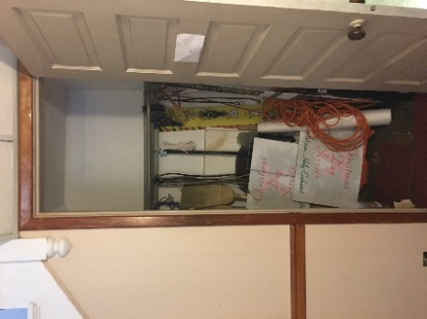
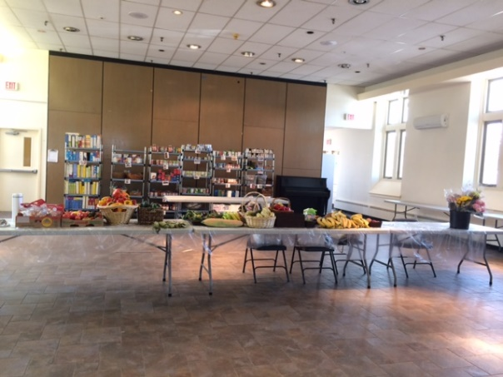

From… To…
Photo courtesy of Karen Kaminskas
2-3|Should You Merge Your Pantry with Another Pantry to Increase Your Impact?
Is your pantry struggling to get food, transport food, store food and/or attract enough able and reliable volunteers? Are these issues causing your program to be unable to commit to consistent hours for your participants? Are you able (directly or indirectly) to provide your participants with additional programming such as job training, nutrition education classes or English as a Second Language (ESL) classes? Are there other pantries in your area open on the same days and at the same hours? If your program does not have the resources to address these issues, you should consider starting a conversation with other area food pantries about ways you can join forces with them to help your neighbors put food on the table. It might even make sense for a pantry to close and move its inventory and resources – including volunteers – to another nearby pantry.

3 Partnering with other organizations
3-1|Special Partnership Opportunities for Montgomery County Food Pantries:
MontCo Anti-Hunger Network, Regional Coalitions and Peer Learning Circles
MontCo Anti-Hunger Network
Montgomery County has a unique initiative called the MontCo Anti-Hunger Network (MAHN). MAHN was initially established in part to improve food distribution throughout the county by determining how best to accept and disseminate large-scale food donations. While still important to MAHN’s mission, the work of MAHN has since expanded to include:
- Network building
- Sharing knowledge and information
- Raising awareness about hunger in the county
- Encouraging pantries to get involved in advocacy
- Establishing and nurturing relationships with other key food-related organizations in the region
- Sharing of excess food between pantries
- Supporting five regional coalitions of pantries
- Holding an annual conference
To subscribe to the MAHN quarterly newsletter for updates about programs and resources for your food pantry, as well as hunger advocacy updates, go here.
Regional Coalitions
Whether you are with a new or established pantry, there is a place for you at your nearest regional coalition meeting. These meetings serve as a way for pantries to partner with other pantries serving their immediate geographic area. To find the current regional coalition contact information, go here.

Peer Learning Circles
Another wonderful way to network with fellow Montgomery County food pantries is to attend periodic Peer Learning Circle meetings. These facilitated meetings bring together food pantry leaders and volunteers to discuss topics such as utilizing client survey results, creating a culture of advocacy and how best to meet pantry participants’ needs beyond food, among others. The MAHN newsletter mentioned above will announce upcoming Peer Learning Circle meetings.
Additional Food Resources in Montgomery County
Refer to Appendix B for other sources of food for your clients in need of additional food.
Is a Referral Needed?
Some food pantries request that participants bring a voucher or referral to their site before they will provide them with food. This can often serve as a barrier for participants to access food because they must first get a referral from a site like a local politician’s office or another social service provider. Pantries should consider carefully before implementing this practice. Open access is considered a best practice.
If you are only able to provide food to a small group of people, communicate these guidelines clearly to your community partners including other area food pantries. Also, have a plan in place to address individuals who do come to you for food who are unaware of your referral policy. For instance, some pantries have food to provide for the first visit along with a list of other pantries that the participant can visit in the future.
3-2|Partnering with Other Social Service Programs in Montgomery County to Meet Your Participants’ Non-Food Needs
When participants need food, they are also most likely lacking other basic services. To help your pantry address your participants’ non-food needs, partner with social service programs that specialize in addressing those areas. Depending on the program and your space, you may arrange to bring these service providers into your pantry periodically so your participants can meet face-to-face with them. You may also provide referrals to their organizations or hotlines. The programs listed below provide a range of services targeting additional needs your clients may have.
- Pennsylvania 211 Southeast is a hotline serving Greater Philadelphia providing connections to health and human services programs. Dial 211 or search their services database. Organizations are responsible for updating their information, such as pantry days and hours of operations, to ensure accuracy.
- Visiting Nurse Association – Community Services (VNA – CS) Personal Navigator Program* is a consolidated, one-stop benefits access program that offers access to up to 22 different benefits such as SNAP, CHIP, Medical Assistance (also known as Medicaid), the health insurance marketplace, LIHEAP, property tax and rent rebate, Medicare related benefits, pharmaceutical assistance programs, health insurance counseling and more. They have four service locations: Abington, Colmar, Norristown and Pottstown.
- Montgomery County Community Connections is a free service that can assist with referrals to social service agencies including: behavioral health, veterans affairs, addiction services, affordable health care, clothing, child care/subsidized child care, developmental disabilities, housing, taxes, aging and adult services, affordable legal advice, women’s health, early childhood education and food. Community Connections employs skilled human service professionals (called “Navicates”) who can be reached by phone at 610-278-3522 or by visiting any of the Community Connections offices Monday through Friday from 8:00 am to 4:30 pm. Online referral assistance can be accessed here. Assistance can be offered in any language using a language line. Community Connections has offices located in Lansdale, Norristown, Pottstown and Willow Grove.
- CADCOM* (Montgomery County Community Action Development Commission) is an anti-poverty agency in Montgomery County assisting clients with programs such as SNAP, LIHEAP, tax assistance and asset development. A SNAP Outreach Coordinator can come to your site to screen pantry participants for SNAP benefits and complete the application.
- Your Way Home Montgomery County Hotline* is a centralized system for screening and intake for Montgomery County residents experiencing homelessness.
- Resource Guide for Norristown Area is a local resource guide for the Norristown area of Montgomery County, compiled by the Norristown Hospitality Center.
- Resource Guide for the Main Line is a local resource guide for programs and participants located on the Main Line (Lower Merion and Narberth) area of Montgomery County, compiled by ElderNet.
- Common Grounds Food Service Training to Employment Program* is a free, 14-week training program in Montgomery County that engages trainees in experiential learning, contributing to food production in Manna on Main Street’s mission-driven kitchen and service at its Common Grounds Café and Common Grounds Catering Program, gaining additional job-ready experience.
- Getting Ahead in a Just-Getting-By World* is a 16-session curriculum that invites people living in poverty to investigate solutions to help themselves, others and their community transition out of poverty and instability.

*Contact information for these programs can be found in Appendix C.

Assisting Your Clients Beyond Food
Food pantries can provide space for other organizations to offer their services during pantry hours. Some pantries have a room for a visiting nurse and others make space for a monthly visit from a SNAP Outreach Coordinator.
When representatives from other organizations come to provide their services, be sure to take the time to properly introduce them to your participants. You have established a level of trust with your participants that your partners will not have the time to develop in one visit. Ideally, announce their attendance starting the month before their visit. You can also post flyers and handouts in advance so participants know they are coming.
Another important service your pantry can offer is to accept mail for participants without addresses. This will provide a stable address for them to get mail when searching for employment and benefits. Many can lose SNAP or other benefits because they did not receive their renewal mailings. Whether they successfully receive their benefits like SNAP each month will affect whether and what they eat.
Finally, make sure you have an up-to-date printed list of other pantries and/or food resources in your community. This can be useful if your pantry is not open at times that work well for participants or if you happen to run low on food. See Appendix B for other sources of food in Montgomery County.

Food as Medicine
Over the past several years, more hospitals and health clinics have begun to see the health benefits of connecting their patients with food resources. Consider reaching out to health care settings to let them know you can help their patients. Also, make them aware that you could use volunteers or help with a food drive, if that is the case. To find out more about addressing food insecurity in health care settings, see this resource from the Food Research Action Center (FRAC), Children’s HealthWatch and Feeding America.

4 Physical/social environment, nutrition and food safety
4-1|Physical Environment
The space where you provide food should be friendly and inviting. You don’t need to spend a lot of money to do this. A clean, well-lit pantry is welcoming to participants and volunteers. Well-trained trauma-informed staff and volunteers will help to ensure that everyone has a friendly and positive experience. Some agencies go beyond the basics and provide empowering and uplifting quotes on their walls. Others have a bulletin board where they post useful information such as special events, election dates and dates when the Navicate or SNAP Outreach Coordinator will be on-site.
Trauma-Informed
The Substance Abuse and Mental Health Services Administration’s (SAMHSA) concept of a trauma-informed approach is “A program, organization, or system that is trauma-informed:
- Realizes the widespread impact of trauma and understands potential paths for recovery;
- Recognizes the signs and symptoms of trauma in clients, families, staff, and others involved with the system;
- Responds by fully integrating knowledge about trauma into policies, procedures, and practices; and
- Seeks to actively resist re-traumatization."
Here are some other things to consider when planning and assessing your pantry space:
- A private space for intake and case management so participants can feel comfortable speaking freely.
- Accessibility for wheelchairs, scooters, walkers and canes. If you are unable to accommodate wheelchairs, how can you make sure your participants are not waiting outside in the cold or the heat? Will someone with bad knees be able to bring their shopping cart down a long flight of steps? If your space cannot accommodate wheelchairs, provide the participant with food before they leave, and refer them to a wheelchair accessible pantry in your area for future visits. Alternatively, some pantries arrange to deliver food to those who cannot visit the pantry due to physical limitations; others allow friends or family members to pick up the food for the participant.
- Do you have accessible restrooms that your participants can use? Do you regularly check to make sure they are clean and equipped with soap and paper products? Are the restrooms wheelchair accessible?
- Do you have an indoor, temperature-controlled waiting area for participants?
- Is the temperature kept at a comfortable setting for participants and volunteers?
- Is your food storage shelving sturdy, clean and at least 4 inches from the wall?
- Is your food stored at least 6 inches off the floor?
- Where will you keep and handle your trash, recycling and compost?
- How can you make your pantry a choice pantry? (See information about choice pantries below.)
- How will you control pests like rodents and cockroaches?
- How will you keep the space, including the equipment, clean?
- Does your electrical service support both 110V and 220V appliances like freezers and refrigerators?
- Is there enough space between your appliances and the walls to allow for proper ventilation? Similarly, do you have adequate air circulating to keep your appliances from overheating?
- Does your space meet fire codes? For instance, do you have exit signs and clearance to exits? Do you have properly functioning fire and carbon monoxide detectors?
- Is your program covered by insurance for falls, fires and floods? If you are a tenant hosted by another agency or sponsor, consult with them to make sure you are covered by their insurance.
If you are not currently addressing the issues above, look for a donor to pay for some of the necessary fixes and/or find a qualified volunteer to help you. If these needs are overwhelming, consider whether you should continue operating and/or find another community partner.
Which Food Distribution Model is Right for Your Program and Community?
Choice, Pre-Packaged and Hybrid Pantries
When you visit other pantries to do your research, you may notice that some food pantries have shelves of food where participants can decide what foods to take. This is known as a “choice” pantry. More and more pantries are becoming choice pantries because allowing participants to decide what foods to select from the pantry shelves provides a measure of dignity for them. Choice food pantries also generate less food waste because participants can choose foods they want to eat and know how to prepare, and pantries can manage their inventory appropriately. A choice pantry also can help address the potential cultural food needs or food allergies of participants. Some choice pantries have shopping carts for participants to use. Other choice pantries operate by allowing participants to choose the foods they want from a computerized kiosk or a paper checklist; volunteers then gather the requested foods and bag them up for participants.

Lack of Space Shouldn’t Prevent You from Becoming a Choice Pantry!
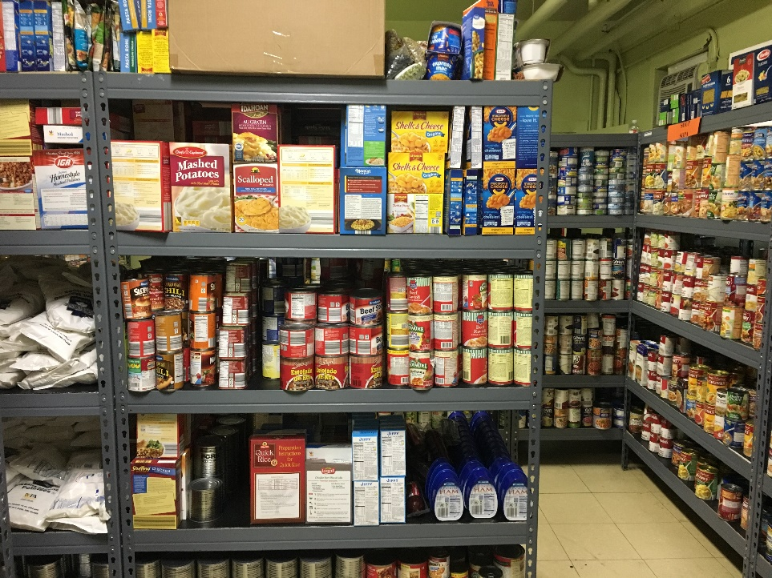

Don’t allow space limitations to keep you from becoming a choice pantry. The Salvation Army of Norristown transitioned from a pre-bagged to a choice operation with just 500 square feet!
Photo courtesy of The Salvation Army

Other pantries may take the food that they have available and pre-pack bags usually based on household size. They distribute these pre-filled bags when participants come to their site. This method of food distribution is easier to provide food to participants quickly, but the foods may not be suited to the participants’ needs or preferences. To discourage waste, some pantries that pre-pack bags have a table where unwanted foods can be left for other participants to add to their bags.
Some operate a pantry that is a hybrid of both the choice pantry and the pre-packaged model. For instance, the pantry may have pre-packaged bags of food, but also a table of fresh produce or other items that provide some choice to participants. While this distribution system does not offer the same level of choice as a full choice pantry, it does offer more than the pre-packaged option. One Montgomery County pantry that operates a hybrid model is Daily Bread Community Food Pantry. Read about them on next page.
When looking at food distribution models, other factors to consider include whether to give out food according to household size or give each household the same amount of food.
Advice on Converting Your Pantry to a Choice Pantry
“When looking at choice pantries, visit a couple because everyone does it a little differently depending on things like space, whether they get state food or have special foods like low-salt or gluten-free. See what feels comfortable for your space. Before we got started, we visited the choice pantries at Manna on Main Street and Pottstown Cluster. We have been a choice pantry for 4 years now.
- Stu Bush, Executive Director of The Open Link Food Pantry

“I was saving my last $20 for the grocery store because I never know what I’m gonna get at the pantry. Today I’m bringing home what I need and I still have my $20!”
- Brenda, a Salvation Army Norristown participant, commenting on how the pantry’s conversion from pre-packed bags of food to a choice pantry helped her.

A Hybrid Food Pantry: Daily Bread Community Food Pantry
Daily Bread Community Food Pantry is a unique hybrid food pantry. While our clients wait in our waiting room, they may choose books from our free library, select school supplies or even get their hair cut if a stylist is available. When they register at our registration table, they are given a diabetic bag, if needed, a baby bundle if they have a newborn or a birthday box for any child 17 years old or younger in their household who is celebrating a birthday that month. (Descriptions of these special bags and boxes is included in Appendix E.) While at the registration table they are asked about any dietary restrictions or allergies. Their order is then communicated to our team in the warehouse – by walkie talkie – and their food is placed in a wagon.
While a team is gathering their warehouse food, they can shop for items in our choice room: ethnic foods, fresh produce, donated Wawa items, baked goods and bread. Other items may include: spices, lunchbox items, seeds for planting, rescued restaurant food and gluten-free food if needed. While the clients are shopping, volunteers talk to the clients about their pet food and personal care needs. When they are finished shopping and leave for their car, they are met outside with volunteers ready to load their food into their cars.
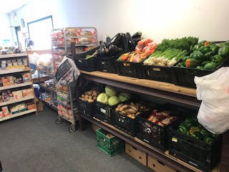
Well-stocked shelves at Daily Bread Community Food Pantry – a hybrid pantry.
Photo courtesy of David Stever

4-2|Social Environment
Customer service and friendly interactions with participants are essential to a well-functioning food pantry. Many food pantries emphasize the importance of greeting everyone by name and having staff and/or volunteers wear nametags so that the pantry experience is more personable. They take the time to talk one-on-one with participants and get to know them. One Montgomery County pantry incorporates a culture of “CPR” into everything it does – Compassion, Patience and Respect – so that participants feel that they have come to a place where they belong and are cared for without judgment.
There are free trainings available to your staff and volunteers that can increase their understanding about poverty, trauma and mental health. All staff and volunteers should strongly consider taking the Bridges Out of Poverty training to increase their awareness of the experience of poverty and to recognize their own biases. Mental Health First Aid gives people the skills to help someone dealing with a mental health problem or crisis. (Refer to Appendix C for information and referral contacts for both trainings.)
Here are some additional practices that can help make your food pantry a more comfortable place for everyone:
- Listen to your participants’ stories. The clothing they wear and the vehicles they drive do not necessarily fully communicate their situation.
- Ask your participants for their ideas to make services better and incorporate their feedback, when appropriate. Listen to the people you are serving. Bring participants into conversations.
- Provide services in the language a participant feels most comfortable communicating in. This may require your pantry to use a language line, looking for additional volunteers or paying a small stipend to have someone help with translation. (Refer to Appendix C.)
- Create and post signage like Manna on Main Street’s Community Contract below that states your pantry’s commitment to and expectations for the community. Review this verbally with staff, volunteers and participants regularly.
- Working at a food pantry is very rewarding, but it can also be stressful at times. Remember to take care of yourself; remind your coworkers, volunteers and participants to take time out to check-in with themselves. Self-care does not have to be expensive and can even be free. You can simply take a few minutes to sit quietly, decompress and get the thoughts floating around in your head written on a piece of paper or a journal. Everyone has his or her own way to unwind and relax. Whatever that is, take the time to do it!
Following are examples of customer service practices at Chelten Seeds of Hope Food Pantry and Manna on Main Street. These examples demonstrate how these pantries made their participants feel valued and respected.

Where Everybody Knows Your Name
At Chelten Seeds of Hope Food Pantry, the food they give out to their participants is essential, but to them the food is always secondary to participants first feeling safe and cared for.
As the program grew over the years, they decided to use Member Track™ software to provide pantry member identification cards to participants. This cut down on the pantry staff and volunteers asking for the same information at every visit and allowed for enhanced and more streamlined data collection. What no one anticipated was how excited participants would be about having a card! They reported that the card gave them a sense of security and made them feel that they belonged to the Chelten Seeds of Hope community.
The card is created after someone visits the pantry a few times. The participant is told that their card will be created at the following visit. Many dress up for the picture-taking event, and after receiving their card very few ever lose it.
Volunteers and staff at Chelten Seeds of Hope see many participants come through their door each month, and while they may know their participants, they may not remember every person’s name. Having the member identification card has allowed them to call each person by their name to continue to provide personalized and friendly service even as the number of participants grows.

Everyone at the Table
“Manna’s Community Contract was developed by the Manna staff with input from clients through the annual town hall forums we hold. During the annual town hall forums, clients agree on ground rules for the forum and we discuss how people are to be treated at Manna. This informed the development of the Community Contract.

All staff had input during a specially called staff meeting; then a smaller group of staff wrote the Contract for review by the whole staff. Once that was complete, it was presented to the Board of Directors for approval and, upon approval, it was printed and framed.”

- Suzan Neiger Gould, Executive Director of Manna on Main Street

Manna on Main Street
Community Contract
Manna on Main Street values all individuals who walk through our doors.
Everyone within the Manna community – staff, clients and guests, volunteers and donors – will treat each other courteously and with respect, dignity, compassion and integrity.
As members of the Manna community, we agree that we will:
- Welcome ALL who enter our doors;
- Speak to each other with words that express kindness and empathy;
- Treat everyone fairly and in a way that honors their humanity;
- Communicate disagreements without personal attacks;
- Act in good faith to ensure people receive the help they need through our Core Programs or through referrals;
- Follow all Manna’s employee, volunteer and/or client policies and procedures for appropriate conduct.
All programs, which Manna sponsors now and in the future, will be provided with client needs and privacy at the center of our services.

4-3|Nutrition
Besides providing foods that are consistent with the 2015-2020 Dietary Guidelines for Americans you can also combine the access to nutritious foods with nutrition education and cooking classes. How you chose to operate your pantry can have an impact on the health and well-being of your program participants. Here are some ideas of what some pantries in Montgomery County are doing to increase knowledge about healthy eating:
- Health Promotion Council teaches nutrition classes at Manna on Main Street. Manna on Main Street staff have created a Cool Kids’ Corner that contains a kid-friendly area with nutrition education activities and new healthy foods to taste-test. Some of the foods (especially certain produce) at the pantry, may be new to participants so being able to taste these foods and learn new recipes helps to introduce children to nutritious foods.

- Some pantries like the Mitzvah Food Pantries and Manna on Main Street have a point system where one can get more food by choosing healthier food options. Participants are allocated a certain number of points each month based on family size. With this system, more nutritious foods “cost” less than less nutritious foods. For instance, a participant can start with 30 points for the month and Ramen noodles may be 5 points, but a healthier option like whole wheat pasta may be 1 point so the participant can get more food by choosing healthier options.

- Martha's Choice Marketplace at Catholic Social Services of Montgomery County has partnered with dietitians from Villanova University to train peer teachers about nutrition, healthy cooking, demonstration and teaching skills in a year-long bi-weekly program called “Community Cooks.” Following their training, peer teachers receive a stipend to teach three healthy cooking workshops to pantry participants.

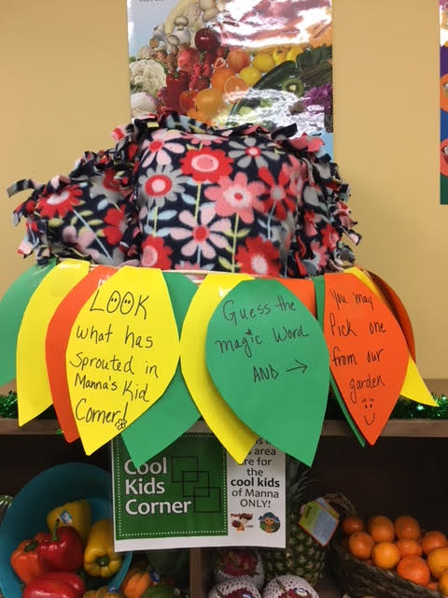
Promoting Good
Nutrition for Kids

The Cool Kids’ Corner at Manna on Main Street serves as a colorful and inviting area to introduce healthy foods to children visiting the pantry.

Photo courtesy of Maureen Plover
(Photo courtesy of Maureen Plover)
v
(Photo courtesy of Maureen Plover)

- Jenkintown Food Cupboard uses a traffic light labeling system on their pantry shelving to indicate the healthfulness of foods using green (healthy), yellow (less healthy) and red (least healthy). Green shelf foods are placed at eye level; yellow shelves are lower and red shelves are at the bottom. They also shelve the foods according to the USDA’s MyPlate five food groups.

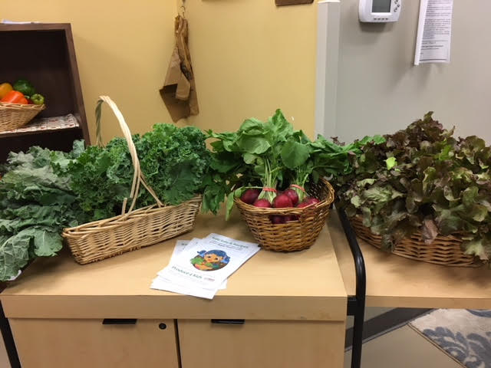
Promoting Fresh
Produce for Kids

Kids can choose what fresh produce they want to try at Manna on Main Street!

Photo courtesy of
Maureen Plover

More Information on Improving the Nutritional Quality of Foods at Food Pantries
- A Tipping Point: Leveraging Opportunities to Improve the Nutritional Quality of Food Bank Inventory
- Consequences of Poor Nutrition
- Why Low-Income and Food-Insecure People are Vulnerable to Poor Nutrition and Obesity
Refer to Appendix D for resources to help you assess foods appropriate for participants’ health needs such as diabetes.

4-4|Food Safety
For food safety and sanitation, you will need to implement practices such as handwashing, wearing gloves and monitoring refrigerator and freezer temperatures as well as implementing a system to manage “sell by” dates printed on food packages.
The Emergency Food Assistance Program (TEFAP) uses USDA specifications for the proper temperatures and conditions in which food should be stored to maintain both food safety and quality.
Below are some useful food storage specifications from the TEFAP Outlet Manual, November 2017 (PA Department of Agriculture Bureau of Food Distribution).

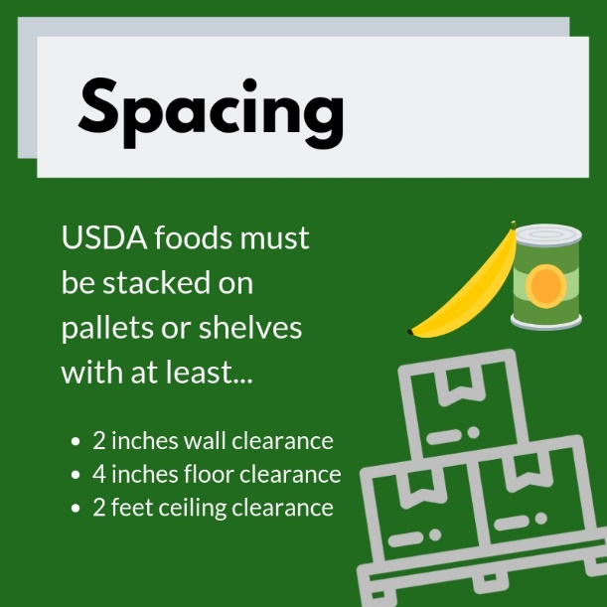
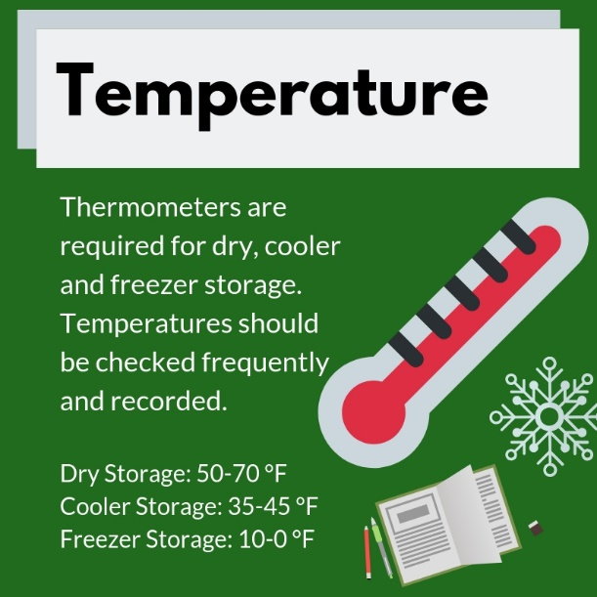
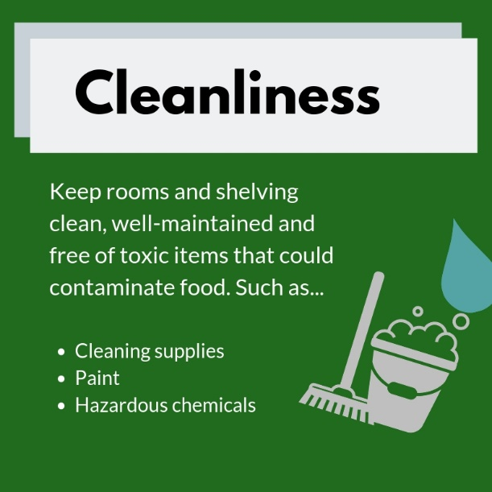
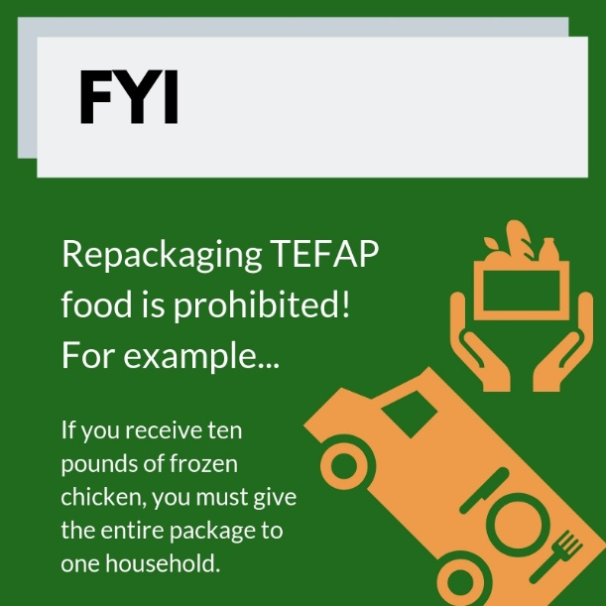

Other food suppliers may have different storage requirements. For instance, Philabundance requires that all non-perishable dry goods must be stored on either pallets or appropriate shelving that has:
- Six inches of floor clearance,
- Four inches of wall clearance and
- Two feet of ceiling clearance.
Be sure to check with each of your food suppliers to ensure you are storing food within their guidelines.
ServSafe Training
Philabundance conducts a food safety training called ServSafe for Food Bankers that is mandatory for members to attend. Two people from each Philabundance member pantry can be trained for free and additional pantry staff can attend for $10 each. The training reviews basic food safety standards. Contact the Community Food Programs Department at Philabundance at 215-339-0900 for more information about the training.
While the Montgomery County Health Department does not require food safety training, it is a very good practice for a food pantry to know how to keep the food distributed to participants safe. If your pantry is not a member of Philabundance, you can also attend other ServSafe trainings that offer certification through Penn State Cooperative Extension or Montgomery County Community College.
What About Those Expiration Dates?
It is important to educate everyone from participants to staff to volunteers on food expiration dates because you do not want to give out food that will make anyone sick. At the same time, if food is perfectly good and safe to eat, you want everyone to know that they are not being given inferior food or food that will make them ill. For many foods (especially non-perishables), the “best by” date means that the taste and consistency of the food may not be at its peak, but the food is still safe to eat. These dates are suggestions from food manufacturers. Currently, there are no government regulations regarding expiration, “best by” or “sell by” dates. To learn more about expiration dates for various foods, go to Philabundance’s website for agency food distribution guidelines. These guidelines are based on recommendations from Feeding America and the USDA.
To communicate about expiration dates, some pantries enlarge, laminate and post Philabundance’s guidelines found above. Some pantries also make copies of the guidelines and share it with all participants and volunteers.

5 finding food for your pantry
While it is not always easy to get the foods you want for your participants, there are several organizations that can help. To maximize your pantry’s food budget, partnering with organizations that can provide free or low-cost nutritious foods to your pantry makes sense. Decrease your program’s dependence on one food source by working with multiple sources.
Following are some of the organizations you can partner with in Montgomery County to get food for your program.
5-1|Philabundance
Philabundance, the region’s food bank, can provide pantries with food at a very reduced fee ($0.19 per pound) through an online ordering system called Agency Express. In addition, members may be able to get additional food through produce hubs throughout the region and grocery store partnerships (known as Grocers Against Hunger or GAH). Other member benefits include grants and funding to increase capacity.

To find out how to become a member agency of Philabundance go here.
You can also find out more about their offerings in the Agency Manual.
Be sure to read over the requirements, which include having regular access to a computer and internet for ordering food and reporting data. Also, you must obtain a minimum of 6,000 pounds of food from Philabundance each year.
If you have additional questions you can contact Philabundance’s Member Relations department at 215-339-0900.
5-2|Share Food Program
Share contracts with Montgomery County government to provide The Emergency Food Assistance Program (TEFAP) and State Food Purchase Program (SFPP) food to Montgomery County food pantries. In addition, Share contracts with Hunger Free PA to provide CSFP (Commodity Supplemental Food Program – also known as “senior boxes”) foods to Montgomery County seniors. Each year, pantries receiving TEFAP food through Share must attend a training and update their Montgomery County Recipient Agency Agreement with Share.
While there is some paperwork to maintain and there are some rules and regulations to follow to participate, most pantries find that these programs are worth it because they provide them with a source of free foods that help them feed more participants, as well as provide more food to each participant. Refer to MontCo Hunger Solutions Emergency Food Package Distribution for more information.
To find out how your pantry can receive food from Share, contact the Director of Share MontCo Hunger Solutions at 610-628-2000 or infoMHS@sharefoodprogram.org.
5-3|Independent Partnerships with Grocery Stores
All major grocery supermarket chains participate in Philabundance’s Grocers Against Hunger Program, but if your pantry is not a member of Philabundance and/or your local independent grocery store is not a member of Philabundance’s Grocers Against Hunger (GAH) Program, consider reaching out to see if they would like to partner with you. When working with grocery stores, make it as easy as possible for them to work with you. For instance, make arrangements and create backup plans to ensure that you can consistently pick up the food.
5-4|Food Drives
Food drives can be a great way to get specific foods for your pantry. Reach out to places such as area businesses, elected officials and schools. Mitzvah Food Pantries reported that their High Holiday Food Drive has been successful in getting much needed nonperishable protein items because they explained clearly why there was a specific need for these foods. Educate donors on what you need so you get more of the foods you want. Discourage donations of foods that your participants do not eat.
Consider offering your program as a resource while asking for food so donors see the benefit of helping people they know. For instance, you may say: “Your parishioners may benefit from our services. Here is information on how to become a participant.”
The Boy Scouts of America and the National Association of Letter Carriers are just two of the organizations that regularly hold food drives and distribute the donations to pantries. Connect with these organizations to see if your pantry can benefit.
Organize a food drive with several pantries by partnering with your regional coalition (see Section 3-1). Working together with other pantries has the potential to increase the reach of the drive. If all partnering pantries are involved, a coordinated food drive can also be less work for each pantry.
If your pantry has storage or food pick-up transportation issues, consider whether asking for gift card donations may be a better option for your pantry.
Don’t forget to send thank you notes along with tax acknowledgment letters to let your donors know how much their donation was appreciated.
5-5|Sharing Food with Other Pantries
The Emerson Good Samaritan Food Donation Act
Some donors may be afraid that if they donate food, they could be sued if someone gets sick from that food. This Act aims to promote food recovery by limiting the civil and criminal liability of donors to instances of gross negligence or intentional misconduct. You can go here for additional details about the Act.

There are many constraints imposed on sharing donated food with other pantries. Yet under specific circumstances pantries may share food.
- TEFAP and SFPP food cannot be shared unless permission is secured through MontCo Hunger Solutions. Call 610-628-2000 or email infoMHS@sharefoodprogram.org.
- Pantries that get food through Philabundance’s Grocers Against Hunger (GAH) Program cannot share this food with other pantries except under specific conditions. Philabundance will allow two pantries to get food from a GAH grocery store if a shared volunteer picks up the food and can deliver it within 30 minutes from the grocery store to the second pantry if there is no refrigerated truck. This should first be approved by Philabundance.
MAHN’s Refrigerated Van

In the fall of 2017, Philabundance awarded MAHN a refrigerated cargo van to build the retail food rescue program, Grocers Against Hunger (GAH). The use of a refrigerated vehicle (pictured in Section 7-2) in this program ensures that perishable foods are transported in compliance with cold chain standards (a supply chain that is temperature-controlled). The goal is to increase network capacity through shared distribution of retail grocer inventory that would otherwise be wasted. The program supplies several under-resourced pantries lacking the means to individually transport or distribute the large quantities of food passed through GAH. Philabundance brings the retail partners to the program, each with the potential to donate several tons of food per year.

Work with your regional coalition to make these important connections. For example, the Pottstown Cluster of Religious Communities (PCRC) partnered with Philabundance to create a regional distribution organization (RDO) where food can be shared amongst Philabundance member pantries served by a hub. Also, Manna on Main Street receives a weekly donation of milk that they share with other members of their regional coalition, the Nutrition Coalition.
These are just a few of the important partnerships taking place in Montgomery County. If a pantry shares food with another pantry, it is very important to track all donations in case there is a food recall that needs to be communicated.
5-6|Requesting Food via Social Media
Ask community members to follow your pantry on Facebook and post your pantry needs there. Several Montgomery County food pantries report that readers are very responsive! Again, ask for specific things you need such as tuna, nut butters or low-sodium foods. Donors appreciate having guidance on what to donate and how to be helpful. Other social media platforms like Twitter and Instagram can also be used to solicit food, other supplies and funds for your pantry.

5-7|Farms/Community Gardens
Local farmers and community gardens can provide a source of fresh foods. Farmers generally welcome and appreciate developing relationships with pantries that help them glean and share extra produce that helps the community.
Register your pantry at Ample Harvest’s website to connect with family gardeners in your area who have excess produce to share with your pantry.
Gleaning it the act of collecting or harvesting excess fresh produce from farms, gardens and other agricultural centers.

Excess ripe fresh produce donations from local farms and gardens can be an issue for many pantries especially during the harvest season due to how quickly the produce can turn. This is yet another great reason to partner with other area pantries to share.
5-8|Addressing Food Allergies and Sensitivities
Many pantry participants have food allergies or sensitivities and some of the foods they can tolerate can be expensive. If your food pantry can provide foods for participants experiencing food allergies, then you can reduce a lot of stress for that individual and their family.
Montgomery County is unique because it has resources available to address food allergies and sensitivities. The Rachel Way is a pantry where participants with gluten and dairy allergies and sensitivities can go to get free food specific to their needs. In addition, Montgomery County food pantries can partner with Garden of Health to get deliveries of foods from this special dietary foods food bank so that you can provide these foods on your own shelves.
Garden of Health can also work with your food pantry to set up a dedicated space for special dietary foods that are gluten-free, dairy-free, heart healthy and diabetic-friendly, as well as foods free of one or more of the top eight allergens.
“Hello! I just want to thank you from the bottom of our hearts for adding the section for dietary restrictions. We have diabetes, lactose intolerance and gluten issues in our family and we always felt bad for sounding picky when choosing our foods because “beggars can’t be choosers” and yet we were unable to get certain things because of dietary restrictions. What a wonderful addition to your food pantry, and maybe more families can benefit now that you have this option!”
- Client of a pantry working with Garden of Health

As peanut and nut allergies have grown over the years and can be life threatening, your pantry may also consider adding signage about peanut allergies at the entrance of the pantry to let participants know if you have foods containing peanuts on the premises.

5-9|Addressing Cultural Food Preferences
Food not only serves to nourish our bodies with essential nutrients, but also connects us with our traditions. Someone who grows up eating rice at most meals may not be familiar with pasta, may not like it and/or may prefer to eat rice because that is what his or her family has always done. Not too long ago, the Supplemental Nutrition Program for Low-Income Women, Infants and Children (WIC) added tortillas and tofu to their foods list to ensure that they were providing culturally appropriate foods to their participants.
Find out what foods your participants eat regularly to see if you can acquire those foods for the pantry. Manna on Main Street surveyed their participants to determine what vegetables they should grow in their garden. As a result, they started growing okra because the population they were serving shared that they ate this vegetable regularly, and the pantry was not providing okra then.
5-10|Food for the Holidays
Many food pantries give out special holiday meal bags for Thanksgiving, Christmas, the Jewish High Holidays (Rosh Hashanah and Yom Kippur) and Easter. They may have special food drives, partner with local companies or purchase the foods to fill the holiday bags.
Pantries should consider offering appropriate food options for participants of other faiths, too. Ask your participants about their food needs for their particular faith, and if they have special food needs for the holidays they celebrate.
Pantries can purchase pre-boxed holiday meal packages from the Share Food Program for many holidays. For more details, contact Share at 215-223-2220 or order online at www.sharefoodprogram.org.

6 Finding money to run your pantry
Even if you find that you can provide all of the foods that your participants need to lead a healthy life through the programs and strategies discussed in the last section, you will likely still need to have some money for things like transportation, equipment, repairs, space, utilities and staffing.
6-1|Foundations
You can write grants to private or corporate foundations for financial support. Some suggestions of foundations that are interested in funding hunger relief efforts are the Claniel Foundation and the Leo and Peggy Pierce Family Foundation.
You can also research other foundations at The Foundation Center (www.foundationcenter.org/find-funding). There is a fee to become a member of The Foundation Center, but there is an option to join for their Foundation Directory Online Essential for around $50 for one month. The Brendingler Library at Montgomery County Community College also provides access to free information on funders. For additional Foundation Center Funding Information sites, visit their website.
The Regional Foundation Center housed at the Philadelphia Free Library’s Central Location at 1901 Vine Street in Philadelphia offers free and low-cost workshops and programs related to fundraising in addition to access to electronic fundraising databases.
Unless you have someone with grant writing experience working with your pantry, you may want to put together a small committee from your pantry to work together on writing grants. You may also want to reach out to see if there are volunteers in your community with grant writing experience who could help. Partner with other pantries for joint requests and projects, where possible – funders love to support such collaboration!
When considering a grant proposal, most foundations will ask to see various documents including a nonprofit’s annual budget, audited financial statement, project budget, board of directors list, staff list and a copy of the organization’s IRS 501(c)3 determination letter.
Once you receive funding from a foundation, track all report deadlines and at a minimum keep your funder informed about any unanticipated changes that arise. Continue to build a relationship with your funders by letting them know about significant milestones your pantry has achieved and any success stories. You may wish to invite them to tour your pantry, if their schedule allows. Seeing your operation in action can help funders more fully understand your pantry, the services you provide and any challenges you face. This may help you be successful in future requests for funding.
6-2|Fundraising Events
Another way that you can raise funds for your program is by organizing special events or other fundraisers. Many events can take a great deal of time to organize and do not necessarily raise much money, so think through whether your pantry has the time and resources to commit to planning a fundraiser. While events may not always result in money, they can be good “friend” raisers. For instance, the event may introduce your program to an attendee, and they may be willing to donate funds or volunteer time.
You may prefer to encourage outside organizations to hold fundraisers for you. Offer this option wherever you promote donations or volunteering opportunities. This may require someone who works in your pantry to attend the event and share information about the work you do, but this requires far fewer organizational resources than planning an entire event.
One fundraiser that you may be interested in participating in is the Walk Against Hunger sponsored each April by the Greater Philadelphia Coalition Against Hunger. The Walk Against Hunger provides food pantries and soup kitchens with fundraising materials including a unique webpage to promote the event and raise money from your supporters. Funds raised through the Walk can be used by pantries to purchase food, equipment, transportation or pay for staffing. Although a portion of the funds raised go toward expenses involved in putting on the Walk (fundraising materials, staffing and paying for Walk Day expenses), 80-90% of raised funds are re-granted to food pantries. You can register for the upcoming Walk here.
6-3|Individuals
You can set up online fundraising pages for your pantry through services like Go Fund Me.
Amazon has affiliate programs like Amazon Smile through which you register your nonprofit with Amazon and then ask your supporters to choose your organization to receive a small donation when they make purchases via Amazon.
However you get donations, do not forget to send personal thank you notes to donors and acknowledge their donations for tax purposes.
6-4|Religious Sources
If your pantry is affiliated with a congregation, you can ask them for financial support. Also, some national religiously affiliated organizations like MAZON: A Jewish Response to Hunger and the Evangelical Lutheran Church of America are especially supportive of hunger relief programs.
6-5|Additional Resources for Fundraising
Sample fundraising acknowledgements are available at the PA Association for Nonprofit Organization’s website. For more information about fiscal concerns, refer to the Financial Toolkit for Food Pantries.

7 managing your pantry
7-1|Communicating Effectively
Every pantry should have written policies and procedures that are available to everyone involved with the pantry. These guidelines should also be introduced and periodically reviewed verbally during staff and volunteer trainings and participant intake. Consistency in following agreed upon policies and procedures is essential for everyone to know what is expected of them and, ultimately, for a pantry to run smoothly. Patrick Walsh, Pantry Manager at Martha's Choice Marketplace of Catholic Social Services of Montgomery County, shares that participants in one of their programs called Martha’s Coop work together to craft a “constitution” on how they will resolve issues in the group. Martha’s Coop is a cooperative of 16 families meeting biweekly with the goals of building community and ownership of the program by those affected by food insecurity, increasing fresh food access and developing leadership from within the program participant community.
How to Set Up a Food Pantry Advisory Committee
Tips for Developing A Community Advisory Board (more health care-focused, but adaptable to food pantries).

Keeping your staff, volunteers and participants up-to-date on rules, regulations and program changes is essential to managing your program effectively. Some pantries like the Mattie N. Dixon Community Cupboard have volunteers sign an agreement acknowledging that they understand the pantry’s expectations for volunteers. It is important to use appropriate language and not make major changes without providing time to explain and giving people time to adjust. Ideally, you should include voices from participants in the decision-making process with a survey, focus group or hearing the views of an established advisory committee. Finally, always communicate updates and changes to your program such as new hours and days of operation, new food pantry contacts and new or changes to eligibility criteria to all participants, partners, funders and referral providers, as appropriate.
Below are some examples of ways that food pantry coordinators in Montgomery County have thoughtfully and successfully communicated changes to their participants and/or volunteers.
“If we are low on some foods, we find it is important to communicate while participants are still in the waiting room. We let them know, ‘We are light on this, but will make sure everyone gets something.’ You should have the respect to do that.”
- Sandy Knight, Chelten Seeds of Hope

“I laminated clear, simple instructions for volunteers to open and close the pantry.”
- Karen Kaminskas, Ardmore Food Pantry
“After some instances with participants who came to the pantry inebriated and became disruptive with others, Mitzvah Food Pantries instituted a policy that we require sobriety. We will not let anyone leave without food but will make arrangements for a family member to pick up or to deliver to them in the future.”
- Deidre Mulligan, Mitzvah Food Pantries

“If you change policies or procedures, give everyone enough notice. We found that we were spending a lot of our budget on bags for food. When we changed to a policy that participants needed to bring bags each time they visited pantry, we gave them three months’ notice, so everyone knew this was happening, could get used to the idea and be prepared.
It is working well, but you have to give people time to prepare for change.”
- Britt Petersen, Manna on Main Street
“To be able to meet the demand and keep the wait manageable, 3-4 years ago we split customers alphabetically into 2 groups. Instead of coming every week, they could come every other week, but would get the same amount of food at each visit as if they were coming every week. I personally spoke to every customer for 2 weeks in the waiting room about how this would decrease their waiting time, so it was well received. Sometimes you do have to make exceptions to let some people come every week in extreme cases. Blue weeks on the calendar are for A-J and Orange weeks are K-Z.”
- Sandy Knight, Chelten Seeds of Hope

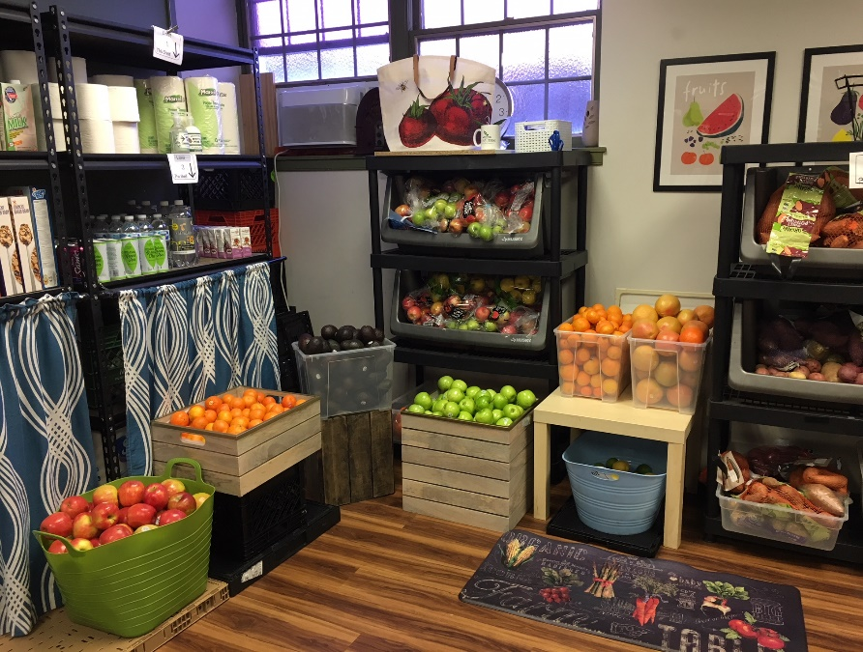
Chelten Seeds of Hope, a choice food pantry, is filled with fresh produce.

Photo courtesy of Sandy Knight

7-2|Transportation
Picking up food donations is a major concern for most food pantries. As was mentioned previously, this is one of the reasons that the MontCo Anti-Hunger Network (MAHN) was first established. To ensure consistent and dependable food pick-up, Mattie Dixon Food Pantry pays a part-time food driver.
It is possible for food pick-up to occur consistently with volunteers. For instance, Chelten Seeds of Hope has a dedicated group of Rotary Club members pick up food every day, Monday through Friday, with a different driver committing to one day.
In 2017, Philabundance awarded a refrigerated truck to the MAHN so that it can more easily pick up, share and distribute food donations to various pantries in the county.

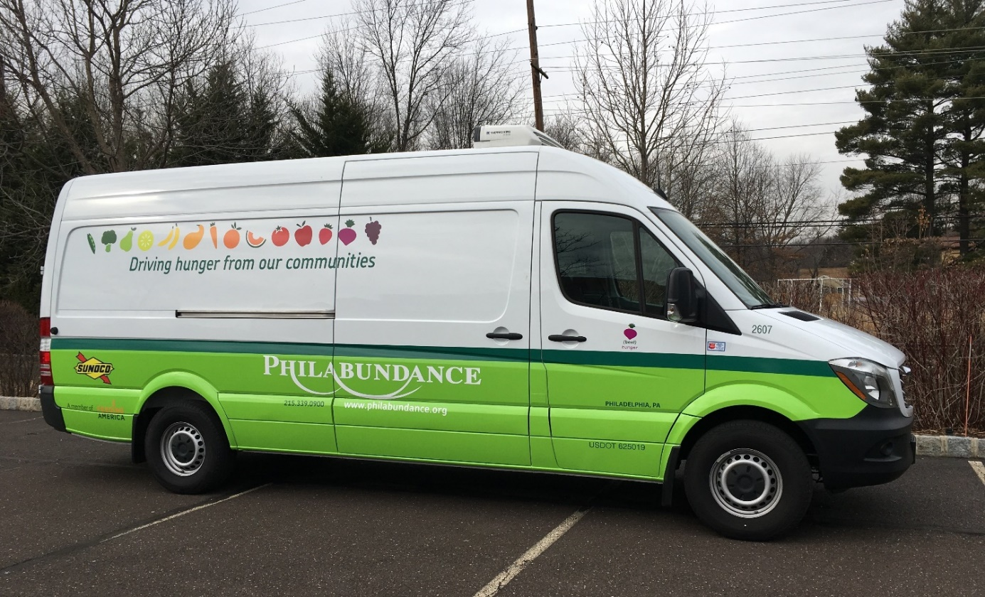
Refrigerated truck awarded by Philabundance to drastically increase the amount of food available to Montgomery County food pantries.
Photo courtesy of Paula Schafer

7-3|Volunteers
Volunteers are essential to running most food pantries. Asking volunteers to complete an application and go through an initial interview process can better determine whether each person is a good fit for volunteering in the pantry and, if so, what tasks he or she may be best suited for.
Take the time to create and implement a standard volunteer training so that all volunteers understand your pantry policies and procedures. Encourage volunteers to attend trainings like Bridges Out of Poverty and Mental Health First Aid to increase their understanding of poverty, mental health and personal biases. You can read more under Section 4-2 Social Environment and see Appendix C for information and referral contacts for both trainings.
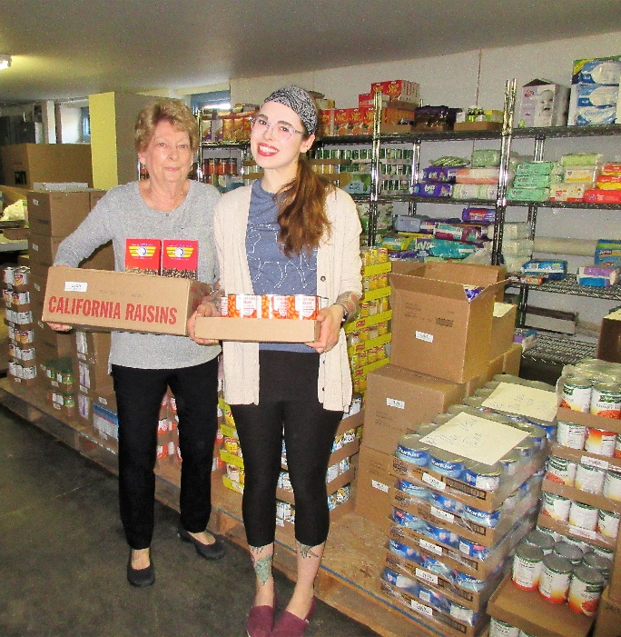
Volunteers are Essential!

The Open Link staff and volunteers work together to provide food for their clients.

Photo courtesy of Kelly Chandler

You can manage volunteers using an online program like Sign-Up Genius. Depending on your volunteer management needs and the number of volunteers you work with, this service can be free or used for a fee. See how Ardmore Food Pantry uses Sign-Up Genius by clicking on the Sign-up Genius icon in the left-hand column of their website.
Should your participants serve as volunteers? Some pantries have participants volunteer at the pantry if they are interested. Others try not to have customers as volunteers but allow them to give back in other ways such as helping to staple and fold bags at stations in the waiting room. One pantry has their volunteers complete a form and sign-off that food is for participants, not volunteers, but volunteers can have extra produce. Whatever your pantry decides, having clear and consistent volunteer policies, procedures and practices is key.
Even after going through an interview process, you may still find that a volunteer is difficult to work with and not respectful of your pantry participants or other volunteers. It is possible to let these volunteers know that it is not working and let them go. Besides taking up a lot of energy and time to deal with, difficult volunteers can detract from a pantry’s inclusive and friendly social environment.
During the holidays, you may receive more requests for volunteer opportunities. If you need volunteers, this is a great way to get extra help and perhaps cultivate them into future donors. On the other hand, some pantries cannot handle the number of people who want to volunteer. If you cannot use the help, refer them to other pantries in need of extra volunteers.
Sharing volunteers is yet another great reason to partner with other food pantries in your community. For instance, your pantry may have volunteers who want additional work hours on days that you are not open. Another pantry may have volunteers who want to work on days that you are open. This volunteer network can benefit all pantries!
Take the time to show your volunteers that you appreciate them. In addition to expressing your gratitude for their work regularly, you can also organize a volunteer appreciation event or provide them with a small thank you gift.
Refer to the Philabundance Agency Volunteer Toolkit, a more in-depth resource on volunteer recruitment, interviewing, training and management.
7-4|Record Keeping (Participant Tracking, Inventory, Contracts, etc.)
The information that you need to track depends on several factors, including where you get your food and funding from and what statistics you need to monitor for future fundraising and program evaluation.
If your pantry receives food through The Emergency Food Assistance Program (TEFAP) food and/or Commodity Supplemental Food Program (CSFP or senior boxes), you will be required to keep records of who is receiving the food to participate in these programs.
To keep track of monthly participation, you can use an Excel spreadsheet from MontCo Hunger Solutions that generates a report. The spreadsheet also has a volunteer time sheet tab that can be useful when writing grants, among other things. Contact Share’s MontCo Hunger Solutions at 610-628-2000 or infoMHS@sharefoodprogram.org for a copy of the spreadsheet as well as training on how to use it.
Another software package useful for keeping track of participant data from one visit to the next is Member Track™ Software. As mentioned previously, this program has transformed the way that Chelten Seeds of Hope collects data and operates. In addition to not burdening participants to answer the same questions at each visit, the software tracks dates when participants visit and has the capability to print out special membership cards which include a participant’s name, photo and a unique barcode. You can read more about this software here.
Pottstown Cluster of Religious Communities, Mitzvah Food Pantries, Manna on Main Street, and The Open Link are currently using a software called SmartChoice™ Food Pantry Software. This software allows pantry participants to order food using a touchscreen at the pantry or from their own computer. Among its many features, it provides real-time inventory management, allows for flexibility in allocating points for foods and has participant tracking features. You can read more about this software here. Manna on Main Street produced an informative video that shows how they use this software.
Keeping track of your inventory is a good idea so you know what foods participants most request and what need to be reordered. Some pantries use a special computer program for tracking inventory, but others decide not to track inventory because it comes in and goes out quickly each month.
What Software is the Best Fit for Your Pantry?
To effectively decide which software to use, you should first determine your pantry’s needs. Next, research what is available and learn what each option allows you to track and report on and, of course, the cost. Call other pantries to inquire what software they use. In addition, research what assistance is available for setup/installation and ongoing maintenance/security and whether these services are included in the quoted cost.

Pantries receiving TEFAP need to keep several forms on file, including the most recent Self-Declaration forms for the year. Self-Declaration forms are paperwork signed by participants confirming their income is below 130% of the federal poverty guidelines. These forms must be kept from the last three years but can be scanned and saved electronically. The TEFAP Record of Civil Rights Training signed forms must also be kept on file.
Collect the necessary information from participants and make sure personal information is locked up safely to maintain confidentiality and prevent identity theft.
To measure impact on pantry participants’ food insecurity, pantries can use a validated two-question food insecurity survey:
- “Within the past 12 months we worried whether our food would run out before we
got money to buy more.”
Often true Sometimes true Never true Don’t know Refused
- “Within the past 12 months the food we bought just didn't last and we didn't have
money to get more.”
Often true Sometimes true Never true Don’t know Refused
Further, this survey can be used to determine if a participant requires additional referrals to other food resources. Collectively the survey results can be used to let funders know the need of your participants, as well as the impact of your program over time. You can read more about this survey from the Oregon Food Bank.

7-5|Caring for Your Equipment
Prevent costly equipment repairs and new equipment purchases by taking the following measures:
- Leave one to two feet between refrigerators and/or freezers if heat evacuates to the side. If units evacuate heat from the back, then keep them one foot from the wall.
- Don’t turn refrigerator and/or freezer temperatures down lower than needed.
- Plug in equipment properly. Each should be on a separate circuit or at least have its own outlet; using extension cords for equipment can pose a fire hazard.
- Keep it clean! In addition to sanitizing the inside of your refrigerators and freezers, make sure to clean the condenser coils regularly. For more specifics you can read this blog post.
7-6|Succession Planning
Who will take over as pantry coordinator or key volunteer positions if the individuals currently in those positions are no longer able to continue? Planning for the future is often difficult for pantries as there are so many other things demanding immediate attention. In fact, the 2017 Southeastern Pennsylvania Food Pantry Coordinator Survey revealed that nearly half (46.9%) of Montgomery County pantries surveyed did not have a formal succession plan or someone trained to take over leadership if the current coordinator could no longer serve.
Take the time to create or update job descriptions and job duties for the pantry coordinator and volunteer positions. Are there current staff or volunteers who could fill some of these positions if needed? If not, consider how you can recruit more volunteers with the necessary skills.
More Information on Succession Planning for Your Food Pantry
Passing the Torch: Ensuring A Solid Succession Plan at Your Agency
Succession Plan in Event of Temporary, Unplanned Absence

8 Advocacy
Advocating for your participants and the programs and policies that keep food on their tables is very important. Some of the programs you may advocate for, like the State Food Purchase Program (SFPP), will affect the amount of food your pantry has available to give out.
Advocacy can take many forms. Everyone has his or her own comfort level with advocacy. Start where you feel most comfortable. You can provide voter registration forms at your pantry, sign a petition or call or visit your elected officials. You can post dates for upcoming elections or ask volunteers to drive pantry participants without access to transportation to the polls on Election Day. You can begin to build a relationship with your elected officials by inviting them to visit your pantry and meet your participants and volunteers.
More Information on Advocacy Rules and Regulations for Nonprofits
Bolder Advocacy

National Council on Aging (NCOA)

Educating others about the struggles that individuals and families experiencing poverty have with food and other basic needs is a very important form of advocacy. Collecting and sharing the stories of your participants can help others to go beyond the statistics in understanding the problem.
Engage the people you serve in this work. One exemplary program is Witnesses to Hunger. Witnesses to Hunger operates with the fundamental understanding that low-income mothers of young children experiencing poverty are the real experts on maternal and child health and poverty and, therefore, must be included in discussions of policies and programs affecting them. Mothers involved with Witnesses to Hunger use their own photographs and stories to create changes on local, state and national levels. To find out how you can engage participants see their toolkit.
The Philabundance Agency Advocacy Toolkit is a great resource that goes into detail about advocating as a nonprofit organization, finding out who your elected officials are and meeting with, calling and writing to an elected official. In addition, it highlights key anti-hunger federal legislation such as The Farm Bill and Child Nutrition Reauthorization, as well as state-level legislation. Finally, the toolkit covers the various trainings available to agencies including Advocacy 101, story collection, voter registration and participant engagement.
You can stay updated on the latest anti-hunger advocacy efforts by signing up for e-newsletters and e-alerts from MAHN’s Food Policy Action Network and the Coalition Against Hunger’s Policy Center.
Some food pantries and nonprofits are hesitant to engage in advocacy because they believe this will affect their standing as a 501(c)3. The truth is that nonprofits can engage in a certain percentage of advocacy depending on the size of their agency budget. Also, you can always advocate as an individual constituent.

9 The future
Due to the current political climate, there is a move toward reductions in public funding for federal food assistance programs like SNAP, but also potentially for programs that provide food and funds to food pantries. Thus, adopting the recommendations in this guide of making pantry operations efficient are even more important! These practices demonstrate to funders and donors a pantry’s commitment to running an effective pantry that better serves participants.
This guide has highlighted many of the best practices of some food pantries currently operating in Montgomery County. The county is fortunate to have so many caring individuals sharing their talents and doing the hard work of helping to make their neighbors’ lives better. Hopefully, your pantry feels encouraged to partner with other food pantries, the MontCo Anti-Hunger Network (MAHN), Share Food Program, Philabundance, the Coalition Against Hunger and others to increase food security in the county. Remember that the MAHN has an established network of regional coalitions that can help you make these important connections. These regional coalitions can be made even stronger with your pantry’s active involvement. The Peer Learning Circle is a unique resource available in the county that can help your pantry continue to build knowledge of ways to best nourish your community. While attending meetings, visiting other pantries and partnering with others require extra time in the short-term, this will be outweighed by the long-term benefits reaped.
Whether you decide to implement a new volunteer training, change your hours of operation so they work better for your participants or something else, may this collection of best practices in food pantries continue to feed you with new ideas to work towards a food secure Montgomery County!
 | By Adopting These Best Practices
If Your Food Pantry Is Like This Now… | Your Food Pantry Will Have… | Your Participants Will Be…
Very few referrals made to other social assistance programs | A SNAP counselor who visits your pantry at least once a month to complete applications | More food secure
Struggling to pick up and store fresh produce | More vegetables available to participants | Healthier
Struggling to pay the bills and meet the needs of program participants | Increased donors | Less stressed
Pre-packed foods pantry | Become a choice pantry | Feel a sense of dignity
Not involved with advocacy | Regular invitations to tour the pantry sent to local elected officials and involve program participants in advocacy efforts | Feel listened to and empowered
Do not have time or staffing to attend regional coalition meetings at all | Regular attendance at regional coalition meetings, and share more ideas and resources with neighboring pantries | More resources, including food
A few dedicated volunteers struggling to open the doors each month | Plenty of help from staff and volunteers | Feel more supported
No volunteer or staff sensitivity training | All staff and volunteers trained in Bridges out of Poverty | Feel more understood and involved in the pantry

Appendices

Appendix A
Food Pantry Assessment: A Summary of Questions
The following list contains a summary of questions drawn from this best practices guide. Your food pantry can use this list as a worksheet to assess the areas that you feel are your strengths as well as those areas where your pantry may want to focus energy on improving. Your pantry staff and board (or decision-making body) should take time at least once a year to reflect on how your pantry is operating. Decide together what you want to prioritize for the upcoming months.
Meeting the Need
- Have you reviewed the 2017 Montgomery County Pantry Client Survey Report? What are your participants’ needs and how will your pantry address those needs?
- Do you periodically review the data on your clients (or inventory) and adjust your program based on the results? Do you need more information to determine your participants’ needs? If so, do you need to conduct a survey or use another method to collect the information?
- Who are your neighboring pantries and what are their hours and days of operation?
- What open hours would best suit the needs of your participants? How can you coordinate your pantry’s days and hours of service with other area pantries so that gaps in service are decreased?
- Does your pantry adjust the amount of food given out depending on household size?
- Does your pantry deliver food?
- How do you serve people who do not have access to a kitchen, stove or refrigeration? Does your pantry stock ready-to-eat foods for this population?
- Do you provide referrals to other food and non-food programs?
- Can clients receive as much food as they need?
- Can clients visit as often as they need to?
Partnering with Other Organizations
- Have you visited other area pantries? If so, which ones?
- Who else can you partner with?
- Are you attending regional pantry coalition meetings?
- Are you attending Peer Learning Circle meetings?
- Have you signed up for the MAHN quarterly newsletter?
- Do you provide additional services on-site?
Physical/Social Environment, Nutrition and Food Safety
- Are you distributing food in the best manner possible for your participants (choice vs. pre-bagged vs. both)? What can your pantry do to improve food distribution at your site?
- Have your staff and volunteers gone through Bridges Out of Poverty and Mental Health First Aid training?
- Is your pantry a pleasant and warm place for participants, volunteers and staff? What can be done to improve the environment?
- Does everyone feel safe at the pantry?
- Are you following current food safety rules?
- Do your staff and volunteers have the proper training?
- What will you do to ensure that participants are served with dignity?
- Do you keep a shared calendar for things like routine equipment inspections, grant report deadlines and volunteer/participant birthdays?
- Do you provide nutrition education on-site?
- Do you have private space for participant intake?
- Is your site handicapped accessible?
- Do you use integrated pest management to deal with rodents and insects?
- Do you show volunteers that you appreciate them?
- Are participants, volunteers and staff all educated about best by dates?
- Do you provide space for a SNAP screener or have some other way for clients to sign up for SNAP and other benefits?
- Is there more that your pantry can do to provide services with dignity?
- Do you update your pastor, director or board of directors regularly on what is happening at the pantry – successes AND challenges?
- Does your pantry ensure client confidentiality?
- Do you have space for storing all the food your pantry needs?
Food for Your Pantry
- Are there other potential sources of good quality, nutritious donated or low-cost food?
- Will you have enough food to meet the need of your participants?
- How will you make sure you are giving out healthy foods to your participants?
- Do you partner with other pantries to share extra resources like food and volunteers?
Resources to Run Your Pantry
- How will you pay for the things that your pantry needs to operate?
- How much money do you need to pay for food, equipment, utilities and space?
- Do you need to add paid staff? If so, what tasks would they need to do and what additional skill sets are you in need of?
- Do you have enough committed volunteers? What type of volunteers do you need?
- Do you have an annual budget?
- Do you have an annual fundraising plan?
- Do you have a succession plan?
- Do you have your recent contracts, records and paperwork on file?
- Does your pantry have a computer and needed software?
- Do you keep track of inventory?
- How do you track program participation?
- Do you assess food security?
Advocacy
- Have you read Philabundance’s Agency Advocacy Toolkit and developed a plan to implement its recommendations?
- Are you signed up for advocacy alerts?
- Do your staff, volunteers and clients participate in advocacy activities?
- Do you have relationships with your elected officials (local, state and/or federal)?
- Have you had elected officials visit your pantry?
Nonprofit Management
- What financial policies and procedures are in place?
- How are you budgeting/tracking revenue and expenses?
- Have you read the Food Pantry Financial Management Toolkit and developed a plan to implement its recommendations?
- What program policies and procedures for staff and volunteers in place?
- Have you read Philabundance’s Food Pantry Volunteer Management Toolkit and developed a plan to implement its recommendations?

Appendix B
Referrals for Other Sources of Food in Montgomery County
Benefit or US Program | What it Does | Eligibility of Citizens | Eligibility of Undocumented Immigrants | Eligibility of Legal Immigrants | Where to Apply
SNAP  (Supplemental Nutrition Assistance Program) | SNAP (formerly food stamps) provides funds to buy food. SNAP benefits are no longer paper coupons – they are Electronic Benefit Transfer cards, which look and work like bank debit cards. | Eligible | Not eligible. However, ineligible members of a household CAN receive benefits for eligible members, such as most children under 18. | Some adults and seniors are eligible; many children are eligible. | Call CADCOM at  610-277-6363 x140 or call toll free  1-877-223-2662 x140 for help applying for SNAP benefits. A representative from CADCOM is available to come out to most pantries once a month to assist participants with applying for SNAP.
WIC (Women, Infants, and Children Special Supplemental Nutrition Program) | WIC provides vouchers to obtain certain nutritious, free foods for pregnant women, nursing mothers, infants and children under age five. | Pregnant women, nursing mothers and children up to age five are eligible. | Eligible | Pregnant women, nursing mothers and children up to age five are eligible. | Call 1-800-WIC-WINS to find the nearest WIC clinic.
School Meals (Breakfast and Lunch) | School meals provide free and reduced meals for children at their schools. | All children from low-income families are eligible. | Eligible | All children from low-income families are eligible. | Available at children’s schools.
Summer Food Service Program | Organizations throughout the county serve as sites to provide nutritious meals and snacks to children during the time of year when schools are closed, and regular school meals are not available. | Eligible | Eligible | Eligible | Available mid-June to end of August. Call the Coalition Against Hunger’s Summer Meal Hotline during the summer at 1-855-252-MEAL (6325) or text “FOOD” or “COMIDA” to 877877 for a list of sites. Call Nutritional Development Services (Archdiocese of Philadelphia) at  215-895-3470 to find out how to become a summer meal site.

Benefit or US Program | What it Does | Eligibility of Citizens | Eligibility of Undocumented Immigrants | Eligibility of Legal Immigrants | Where to Apply
MANNA (different organization than Manna on Main Street) | Cooks and delivers nutritious meals to neighbors in the greater Philadelphia area who are battling a life- threatening illness. Offers 11 different dietary modifications to accommodate needs of various chronic health conditions. | Individuals (and any dependents under 18) in the Greater Philadelphia area who are battling a life- threatening illness. | Eligible | Eligible | Contact MANNA’s Nutrition and Client Services at  215-496-2662 x5.
Jewish Relief Agency (JRA) | Delivers a free box of kosher food once a month, regardless of religious affiliation. Recipients must live within JRA’s service area in Philadelphia and  surrounding counties. | To be eligible for JRA’s services, you must:  -Have a household income 150% or less of the Federal Poverty Level  -Live within one of the ZIP Codes that JRA services (See website.)  Some exceptions may apply. | Eligible | Eligible | For questions, information or to request services, contact 610-660-0190 or gethelp@jewishrelief.org, or complete the online form.
Aid For Friends | Program delivering a week’s supply of frozen meals once a week to anyone who is in need, isolated and homebound. | Eligible | Eligible | Eligible | Contact 215-464-2224.

Benefit or US Program | What it Does | Eligibility of Citizens | Eligibility of Undocumented Immigrants | Eligibility of Legal Immigrants | Where to Apply
Fresh For All | Philabundance offers free produce year-round, weather permitting. No ID or registration is required, but you must bring your own bag, box or cart. | Eligible | Eligible | Eligible | Tuesday from 1:00-2:00pm at Grace Bible Church at Main St. and Summit Ave., Souderton, PA 18964.  Call Philabundance at 215-339-0900 or Keystone Opportunity Center at 215-723-5430 for more information.
Farmers’ Market Nutrition Programs for Seniors  and WIC | WIC recipients and low-income seniors can receive $20 in vouchers to use annually at many farmers’ market usually from June until the end of November. | Eligible | Eligible | Eligible | WIC families will receive their vouchers from their WIC office. Call  1-800-WIC-WINS to find the nearest WIC clinic.  Low-income seniors can contact Montgomery County Aging and Adult Services (MCAAS) at  610-278-3601 for information about applying.
Senior boxes  (also known as CSFP-The Commodity Supplemental Food Program) | Qualified seniors receive a monthly box of food that contains a variety of basic staples aimed at improving their health through better nutrition. | Participants must be 60 years of age or older and meet income guidelines. | Not eligible. | Some seniors are eligible. | Contact MontCo Hunger Solutions at  610-628-2000 or infoMHS@sharefoodprogram.org.
Meals on Wheels and Senior Congregant Meal Sites | Free meals for seniors 60 and older. | Eligible | Eligible | Eligible | Call Montgomery County Aging and Adult Services (MCAAS) at 610-278-3601 to go through an assessment or go to their website.
Soup Kitchens/  Food Pantries | Provide free prepared meals or distribute food for preparing at home. | Eligible at all sites | Eligible at all sites | Eligible at all sites | Visit the MAHN website or call Montgomery County Community Connections (MCCC) at  610-278-3522.

Appendix C
Contact Information for Montgomery County Non-Food Referrals
Resource | Details | Contact Information
Client survey assistance | For assistance with surveying pantries in Montgomery County about their participants’ specific dietary needs or to get a copy of the Montgomery County Pantry Client survey form. | For assistance in surveying, call MontCo Anti-hunger Network (MAHN) via Share Food Program at 215-223-2220.  For specific dietary needs, call Garden of Health at 267-664-4397.
SNAP | Assistance with SNAP pre-screening and completing applications. | CADCOM SNAP Outreach Coordinator 610-277-6363 x140.  Visiting Nurse Association Community Services (VNA – CS) Personal Navigator Program. Call 1-800-591-8234 for more information or to schedule an appointment with a Personal Navigator.
Housing – Your Way Home Montgomery County | The county’s unified and coordinated crisis response system for families and individuals experiencing or at imminent risk of homelessness. | Call 2-1-1 or 1-866-964-7925, text 898-211 or visit the website.  Anyone experiencing homelessness should call 2-1-1 for screening and intake.
Common Grounds Food Service Training Program | A free, 14-week food service training-to-employment program for the economically disadvantaged in Montgomery County. | Manna on Main Street  ProgramAssistant@mannaonmain.org or 215-855-5454.
Mail service | Allow participants to have mail delivered to your pantry so they can have a stable address. | Norristown Hospitality Center offers this service to clients. Call 610-277-1321for information on how they manage this service.
Translation assistance | TransPerfect is a translation service used by Manna on Main Street. | Call TransPerfect at 215-972-0810.
Mental Health First Aid | An eight-hour free course that gives people the skills to help someone who is developing a mental health problem or experiencing a mental health crisis. | Contact Southeast Regional Mental Health Service Coordination Office: regional.mh@pmhcc.org or  610-313-0924 or 610-313-0968.

Resource | Details | Contact Information
Bridges Out of Poverty | A customizable training to increase awareness of staff, board, volunteers, etc. of the experience of poverty and to recognize their own biases. | Manna on Main Street  215-855-5454  Pottstown Cluster of Religious Communities  610-970-5995  Catholic Social Services  610-279-7372
Getting Ahead in a  Just-Getting-By World | A 16-week class that invites people living in poverty to investigate solutions to help themselves, others and their community transition out of poverty and instability. | Pottstown Cluster of Religious Communities (called UP3 program, “Understanding Poverty to Plan and Persevere”)  610-970-5995  Manna on Main Street  215-855-5454  Salvation Army of Norristown  610-275-4183  Catholic Social Services  610-279-7372

Appendix D
Additional Nutrition and Health Resources
Resources to Assess Foods for Participants’ Health Needs
- Resources for Foods for Diabetic Participants
- Resources for Foods for Participants with Heart Issues (or At-Risk)
- Resources for Foods for Participants with Celiac Disease or Gluten Sensitivities
Resources for Free Nutrition Education Classes and Related Materials
Each program listed below (except Penn State Cooperative Extension) has a list of specific pantries that they are contracted to work with. If you contact one of these programs, they will let you know which organization is assigned to your pantry. These programs also provide support and training for pantry staff and volunteers looking to create a healthier pantry environment. For instance, they can advise on food placement on shelves to encourage participants to choose healthier food offerings.
- Health Promotion Council – HPCPA@PHMC.org or 215-731-6150
- Einstein Medical Center Montgomery – 484-622-1000
- The Food Trust – contact@thefoodtrust.org or 215-575-0444
- Penn State Cooperative Extension Nutrition Links Program – 610-489-4315

Appendix E
Additional Products Pantries Offer Participants Beyond Food
In addition to food, many pantries provide items which are not covered by SNAP benefits. Offering these items allows pantry participants to further stretch the resources they have:
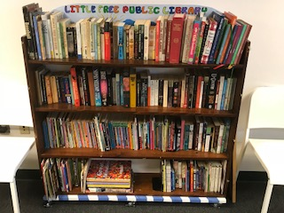
- Clothing
- Cleaning products
- Personal care products
- Pet food
- Books

Free books at Daily Bread Community Food Pantry
Photo courtesy of David Stever

Additional Offerings by Daily Bread Community Food Pantry
Birthday Boxes
This program began at Daily Bread Community Food Pantry as a special event for kids and has now become a formal program of the pantry. Groups from Girl Scout troops to churches donate items for the birthday boxes. Each child from a family who comes to the pantry may request a box. A birthday box is packaged in a plastic box filled with age-appropriate items for a child’s special day. For instance, a typical box for a small child may contain cake mix, frosting, birthday cake candles, party napkins and plates, streamers, balloons and a toy like Playdoh or bubbles. A box for a teen may include gum or a stick of deodorant in place of the toy.
Loretta Stever, Executive Director of Daily Bread Community Food Pantry, shared how she was struck by just how important the boxes can be for many families. Once, a father was brought to tears when he learned that he could get a box for his daughter. He told Loretta, “I didn’t think I’d be able to give her anything special for her sixteenth birthday.”
Baby Bundles
When a parent brings their newborn into Daily Bread Community Food Pantry for the first time, they are given a special bundle filled with items for the baby. A baby bundle includes the following: packets of newborn and stage one diapers, a new blanket (often handmade by a group of seniors), a pack of baby wipes, a baby bottle, a rattle or other baby toy, a small bottle of baby shampoo, baby-friendly soap and a new book. The pantry asks for items to be donated individually instead of premade bundles so there is uniformity from bundle to bundle.

Appendix F
About HealthSpark Foundation
HealthSpark Foundation works with health and human services organizations in Montgomery County, PA to build a more resilient safety net system.
In 2018, HealthSpark launched a new Safety Net Resiliency Initiative. This 10-year effort aims to improve the ability of Montgomery County’s health and human services safety net system to weather uncertainty and meet the needs of county residents.
The Resiliency Initiative will provide grants, education, training and related investments to support those interested in improving the strength and flexibility of the health and human services safety net system. The foundation believes the value and relevancy of this initiative will be enhanced by learning from consumers’ and providers’ ideas and recommendations for strengthening services, so the initiative will engage those groups in shaping the specific projects the initiative will fund.

Visit www.healthspark.org to learn more, get involved and stay connected.

About the Coalition Against Hunger
For more than two decades we have fought hunger in the Greater Philadelphia region with one guiding principle. Hunger is preventable.

Our Mission: Founded in 1996, the Greater Philadelphia Coalition Against Hunger strives to build a community where all people have the food they need to lead healthy lives. The Coalition connects people with food assistance programs and nutrition education; provides resources to a network of food pantries; and educates the public and policymakers about responsible solutions that prevent people from going hungry.

We fight hunger through a three-pronged approach:
- Immediate Relief: We connect people in need to food pantries and soup kitchens in their neighborhood, often able to find an option that will provide food that very day.
- Short-Term Relief: We help people apply and obtain SNAP (food stamp) benefits through our SNAP Hotline.
- Long-Term Relief: We advocate on behalf of those who face food insecurity to ensure that they have a voice in shaping responsible solutions to hunger in both local and national policy recommendations.

Join us at www.hungercoalition.org to find out more about our work and how you can get involved.

About MontCo Anti-Hunger Network (MAHN)
In 2013, what’s now known as MAHN was created to resolve a variety of distribution challenges experienced by several area food pantries. Agencies were not equipped to quickly share unexpected donations of fresh food that were too large for their exclusive use. Coordinating on the fly with multiple pantries was time consuming and complicated. Their varying capacities to transport, store and distribute fresh food promptly were among the obstacles encountered.
With financial support from the North Penn Community Health Foundation (NPCHF) (now HealthSpark Foundation), the leaders of these agencies formed a task force to explore and tackle some of the problems around large scale, fresh food donations. In a broader context, they also began thinking of ways to increase the availability of fresh food to all county pantries. NPCHF granted the dollars to launch MAHN in 2014.
In 2015, MAHN partnered with Philabundance to establish the region’s first Feeding America Redistribution Organization at the Pottstown Cluster of Religious Communities. This arrangement allows a designated group of pantries to share food from a rescue program called Grocers Against Hunger. From June 2016 to June 2018, the program has brought more than 110 tons of food to Pottstown. With MAHN’s help, Philabundance also established pantry produce hubs in Lansdale and Glenside providing more than 157 tons of fresh produce from August 2016 to June 2018. In May of 2018, MAHN launched Montgomery County’s first mobile food rescue and sharing initiative (using a refrigerated van awarded to the network by Philabundance) that distributed more than 24 tons of food that year.
MAHN’s countywide network is made up of 32 food pantries. Each belongs to a regional coalition that meets regularly in a peer-to-peer forum where ideas and resources are exchanged and operational challenges are discussed. Some share surplus food. Network members also participate in an annual conference and quarterly continuing education events called Peer Learning Circles where they learn best practices and build relationships with other network service providers.
In 2017, Share Food Program assumed operational and fiscal responsibility of MAHN and hired its first full-time Administrator. With the members of its Governing Board, MAHN works to establish, build and leverage relationships with community stakeholders and partners to support the work of member organizations and strengthen Montgomery County’s food safety net.
MAHN was founded by CADCOM, Catholic Social Services, Keystone Opportunity Center, Manna on Main Street, The Open Link, Philabundance and Pottstown Cluster of Religious Communities.

Visit www.montcoantihunger.org to find nearby pantries, sign up for the quarterly newsletter, subscribe to Food Policy Action alerts and more.

